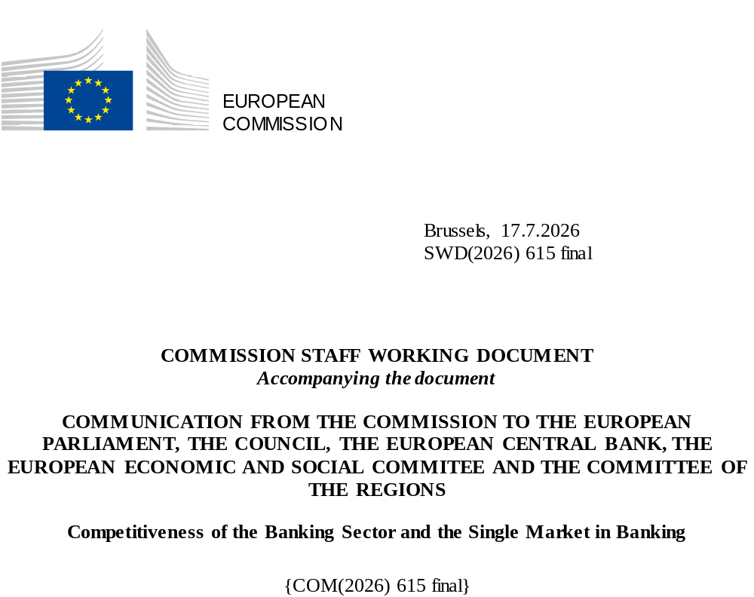

TABLE OF CONTENTS

1. INTRODUCTION 2
2. ECONOMIC ANALYSIS OF THE BANKING SECTOR 3
2.1. The role of banks in the EU economy 3
2.1.1. Lending: EU banks’ core financing function 3
2.1.2. Productivity and bank lending 9
2.1.3. Banks as market intermediaries 11
2.2. Resilience, profitability and market valuations 13
2.2.1. Capital has increased and asset quality has strengthened 14
2.2.2. Profitability has recovered and remains sustained 17
2.2.3. Market perception and valuations 24
3. REMAINING CHALLENGES 28
3.1. Fragmentation of the single market in banking – Main issues 28
3.1.1. Evidence of a fragmented banking sector 28
3.1.2. Fragmentation has resulted in a chronic lack of scale 31
3.1.3. Opportunities and limits to market integration 36
3.1.4. Barriers to market integration 37
3.1.5. Cross-border allocation of funds: efficiency and resilience 42
3.1.6. Safety nets and resolution strategies 43
3.1.7. Liquidity in resolution 46
3.2. Implementation of international standards in the EU – Main issues 47
3.2.1. Output floor 48
3.2.2. Credit risk 50
3.2.3. Market risk and FRTB application 51
3.3. Undue complexity of the framework – Main issues 52
3.3.1. Institutional set-up 52
3.3.2. Micro-prudential requirements 57
3.3.3. Crisis management 62
3.3.4. Macroprudential 64
3.3.5. Transversal issues related to capital stack 66
3.3.6. Proportionality 68
3.3.7. Other issues 69
3.3.8. Prudential framework for investment firms (IFR/IFD) 74

- INTRODUCTION
The Communication of the European Commission on the Savings and Investments Union (SIU) announced in March 2025 that the Commission would publish a report assessing the overall situation of the banking system in the single market, including an evaluation of the banking sector’s competitiveness.
Banks are important to the EU economy, financing and supporting businesses—especially small and medium enterprises—and strengthening capital markets. The contribution of banks to the EU economy ranges from that of smaller banks supporting local businesses to that of larger, internationally active banks able to operate across the Union and beyond. While progress has been made over the past 15 years with regard to resilience and financial stability, undue complexity and inefficiencies in the structure and implementation of the bank regulatory framework remain, with direct consequences on banks’ ability to operate in a more competitive way. Fostering competitiveness of the banking sector thus implies addressing the persisting fragmentation of the single market in banking, reviewing the way the implementation of international standards takes into account EU specificities, and tackling the undue complexity of the bank regulatory framework. Stepping up the competitiveness of EU banks is vital for the SIU and for a competitive EU economy.
This Staff Working Document complements the Communication on the competitiveness of the banking sector and the single market in banking. It provides evidence to support the economic analysis of the EU banking sector as well as an overview of the complexities and inefficiencies of the bank regulatory framework. It is based on extensive research and builds on contributions from a wide range of stakeholders, including the European Banking Authority (EBA), the European Central Bank (ECB) and the Single Resolution Board (SRB), on their experience of the banking activities and the regulatory framework. This includes in particular the feedback gathered during thematic workshops organised by the Commission in September and November 2025, an implementation dialogue with bank representatives in December 2025, the responses to the targeted consultation conducted by the Commission between 11 February to 19 April 2026 and specific outreach activities and meetings with Member States’ representatives, financial institutions, business organisations and representatives from civil society.

- ECONOMIC ANALYSIS OF THE BANKING SECTOR
The EU banking sector has evolved significantly over the past 15 years, adapting to events and responding to the crises that characterised those years, from the global financial crisis (GFC) to the euro area sovereign debt crisis and Brexit, and more recently COVID-19, the Russia’s war of aggression against Ukraine and the war in the Middle East. The sector also benefited from periods of economic growth and has increased its profitability since 2022.
The GFC highlighted that risks to the financial systems do not stop at national borders and financial stability could only be preserved through a common European response: this shaped today’s prudential and supervisory architecture and focused EU action in setting a resilient and robust framework. The subsequent crises tested the resilience of the EU banking sector (and of the financial EU architecture as a whole), demonstrating its strengthened capacity to act as a shock absorber rather than an amplifier. Despite these gains, EU banks continue to trade at low valuations relative to past performances and global peers, reflecting persistent concerns over structural profitability and fragmented markets. This highlights the remaining challenges to the competitiveness of the EU banking sector.

  - The role of banks in the EU economy
The EU operates a predominantly bank-based financial system, in which the banking sector plays a pivotal role in sustaining economic activity. Banks serve as the primary engine of credit creation, investment financing, and monetary policy transmission. These functions are underpinned by the diversity of the banks’ business models and services. This pivotal role is enabled by the structure of banks’ balance sheet, which has historically rested on deposits as the primary and most stable source of funding. Among such deposits, retail deposits provide banks with a resilient and competitive funding base. They are usually less sensitive to market volatility than wholesale financing, reflecting customer inertia and switching costs inherent to retail banking. This relative rigidity, while moderating the speed of monetary policy pass-through, reinforces the stability of deposit funding across interest rate cycles, making such deposits the cornerstone of the EU’s predominantly bank-based financial system. The ECB's Economic Bulletin analysis confirms this conclusion, acknowledging the impact of national banking markets’ structure and remaining differences in the EU deposit insurance frameworks.

    - Lending: EU banks’ core financing function
EU banks are the primary source of financing to the real economy. As of June 2025, the aggregated assets of EU/EEA banks reached EUR 29 trillion equivalent to roughly 80% of EU GDP, with loans and advances accounting for 63% of total assets (EUR 20.3 trillion). Error! Reference source not found.Figure 1 underscores the criticality of bank financing for the EU economy. This aggregate figure hides however substantial variation across different types of borrowers. As of December 2025, 66% of the outstanding loans and advances of EU/EEA banks were extended to households and corporates. Households accounted for EUR 7 trillion (35% of total loans and advances) while corporates represented EUR 6.3 trillion (31% of total loans and advances).

Figure 1: EU/EEA Banks' asset composition.
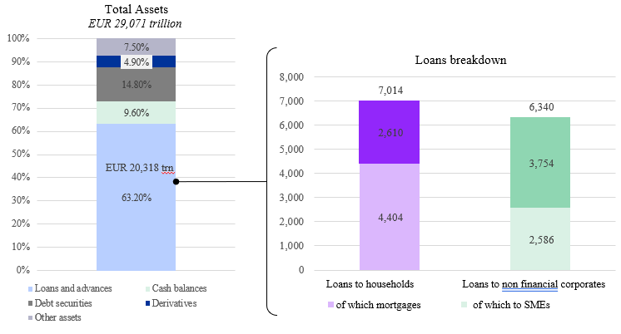
Source: EBA Rish Dashboard (Q4 2025), FISMA calculations
Households lending remains one of the most structurally important functions of EU/EEA banks, primarily through mortgages, consumer credits, and personal loans. Competition in this segment stays robust, driven by a broad network of significant and less significant banks across the EU, as well as enhanced digital channels widening accessibility and streamlining loan origination.
The primary source of corporate funding has consistently been provided by banks, accounting for 46% of corporate debt financing in the EU. This figure has been broadly stable for the past year but decreased significantly (11% gap) since the GFC as banks were forced to deleverage in order to comply with stricter prudential requirements. There are considerable differences between EU Member States in terms of share of bank loans in consolidated corporate debt (12% in Ireland up to 70% in Austria). In parallel, credit provisions by NBFI have increased over the past years, notably via private credit. According to ECB’s estimates, the share of non-banks in the provision of credit to corporates grew from circa 15% at the time of the GFC to circa 30% in 2021.
Figure 2: Share of bank loans in total (consolidated) NFC debt
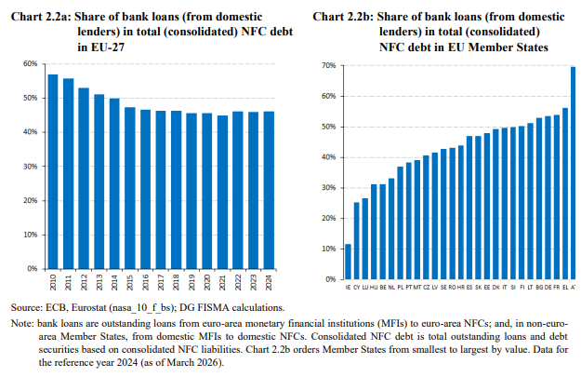
Capital market instruments (listed shares, corporate bonds) remain structurally underdeveloped, especially compared to the UK and the US. Debt securities and listed shares make up only 3% and 14% of corporate debt in the EU, whereas respectively account for 7% and 31% in the UK and 6% and 38% in the US. The ECB's Occasional Paper on the Capital Markets Union notes that while progress has been made over the past decade, European capital markets remain fragmented along national lines, reducing their capacity to allocate capital efficiently across borders. This structural gap reinforces the continued centrality of banks in financing the European economy. The Savings and Investments Union strategy aims at developing scale and depth of the EU capital markets, thus bringing diversification to EU funding markets.
Figure 3: Composition of NFC liabilities in the EU
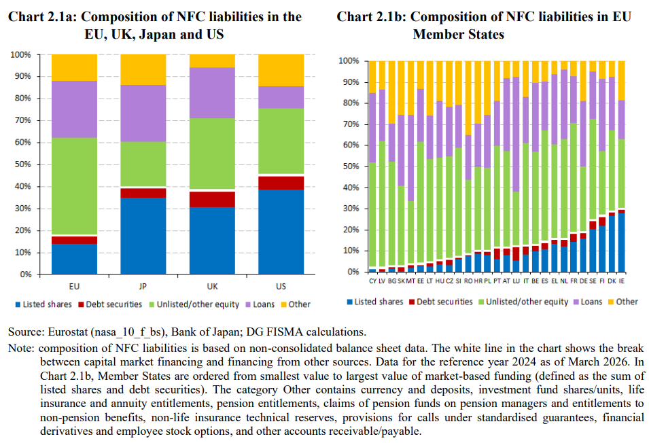
Banks play a particularly critical role for SMEs, providing EUR 2.6 trillion in outstanding loans (40% of banks’ total corporate lending, as per Figure 1) . SMEs are, on average, highly reliant on banks due to their limited access to capital markets, making them vulnerable to any tightening of credit lending, related to underwriting standards or other factors. In contrast, micro-firms tend to rely more on non-bank financing, as alternative sources of funding (such as own equity or other sources which are better suited to funding higher-risk projects that fall outside banks’ risk appetite).
Corporates’ reliance on bank lending differs markedly across sectors. Banks remain the dominant source of external financing for asset-heavy industries, such as real estate, construction, and wholesale trade, where tangible collateral and established credit histories facilitate credit assessment. Commercial real estate lending historically shows the highest bank credit penetration (approx. 25% of total assets of the sector), reflecting the importance of bank debt for this sector made possible by a tangible and relatively liquid pool of collateral. Conversely, sectors with higher productivity potential, such as manufacturing, ICT and productivity-enhancing technology firms fund only a small fraction of their assets through bank lending (circa 4%), relying instead on a more diversified financing mix. For the latter group of sectors, the lack of tangible collateral, coupled with the opacity of early-stage cash-flows often push financing needs beyond banks’ risk appetite. This aligns with the conclusions of the Letta and Draghi reports, highlighting the limitations of bank-based financing for some sectors despite their high productivity and innovation potential, requiring deeper EU capital markets.
Figure 4: Source of funding per corporate sector; 2023
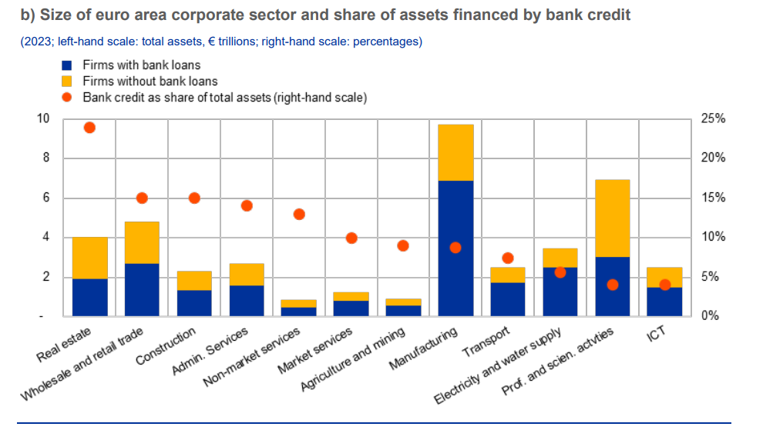
Source: BvD Electronic Publishing GmbH – a Moody’s Analytics company, ECB (AnaCredit, QSA, MNA), European Commission (KLEMS) and ECB calculations, reflected in the Eurosystem's response to the EU Commission's targeted consultation on the competitiveness of the EU banking sector.
Note: Bank credit includes credit lines, loans, trade receivables and overdrafts reported in AnaCredit. A firm is defined as having access to bank lending if it has at least one outstanding credit exposure in AnaCredit or Orbis.

Bank lending behaviour is inherently procyclical: credit expands during upswings and contracts during downturns. When these swings are driven by supply-side factors, they may amplify rather than dampen the underlying economic cycle. However, if banks are well capitalised and profitable, procyclicality of credit supply can be mitigated.

Figure 5: Loan demand and credit-to-GDP gap
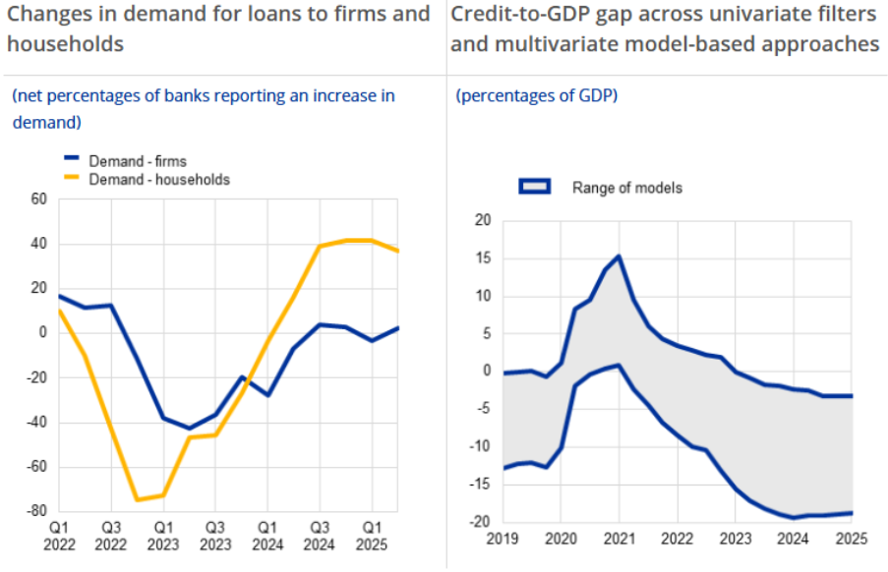
Source: The transmission of monetary policy: financial conditions and credit dynamics. Speech by Philip Lane, ECB Executive Board Member

During the tightening cycle of 2022–2023, banks’ lending growth weakened sharply, in line with the intended transmission of monetary policy. As highlighted in Figure 5 (left had side panel), the net demand for loans from both corporates and households collapsed through 2022-2023, due to higher rates discouraging borrowing for both counterparties, while banks tightened their own credit standards. The tight monetary policy slowed loan demand and therefore pushed credit below GDP (right hand side panel), which was instead recovering from the sharp COVID-19 induced downturn. This gap was not fully offset by non-bank financing, via public or private markets, as banks maintained their central role of credit intermediation in the EU. The credit-to-GDP gap remained wide in 2024, and only slowly started to narrow, as loan demand from corporates and households was recovering. On one hand, this this trend shows how banks are a key component of monetary policy transmission, on the other hand it highlights the need to further develop capital markets to serve as an additional source of financing and mitigate the credit supply difference.
Looking closely at credit demand and supply, the ECB’s Survey on the Access to Finance of Enterprises (SAFE) points to a credit market that is normalisation rather than structurally impaired. The survey evidences an easing of the financing constraints since the post-pandemic tightening cycle: loans’ rejection rates, which spiked sharply across corporates, consumers, and mortgage lending in 2022-2023 as rates rose, have since drifted back toward pre-crisis levels, with only a slight uptick in consumer credit rejections over the past year. At corporate level, actual loan refusals remain rare, with only 1% of firms having a loan request rejected in 2025 (down from 3% in 2024) and overall obstacles to obtaining a bank loan (incl. rejections, declined offers, and partial approvals) fell to 7% from 15% over the same period. This improvement however coincides with a longer-run decline in loan demand itself. The share of EU corporates applying from bank credit has fallen from 34% to 24% since 2014, suggesting corporates are relying less on bank finance rather than being squeezed out of it. For firms that did not apply for bank loans, the most frequently cited reason was that they considered their internal funds to be sufficient to support their business plans. Crucially, these constraints are heterogeneous among Member States and remain systematically higher for SMEs than for large firms, indicating that credit subduedness is concentrated among specific borrower segments and jurisdictions rather than reflecting a broad-based supply crunch.

Figure 6 - Bank loan applications
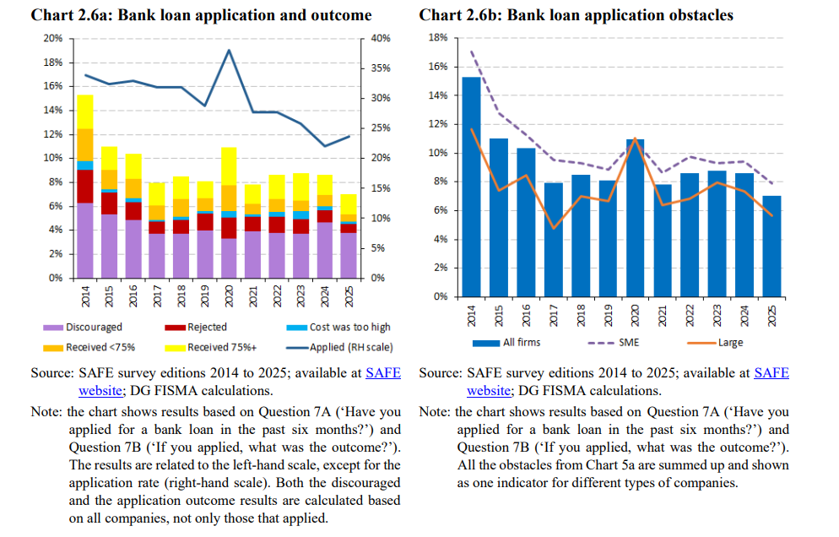
Source: EBA/ECB data.

    - Productivity and bank lending
Total factor productivity (TFP) growth in the European Union, a key variable related to long term economic growth and development, has slowed down since 2000 and has lagged significantly behind that of the United States over recent decades. This productivity gap, which compounds over time into a substantial competitiveness disadvantage, has multiple drivers, but the role of finance and capital allocation is recognised as a contributing factor. Evidence cited in the ECB’s Financial Stability Review special feature on firm productivity underscores the non-linear relationship between bank lending and aggregate TFP: while efficient capital allocation can boost productivity, distortions in lending practices, such as support for low-productivity incumbents or sectorial biases, may instead hinder it.
Figure 7 - Cumulative TFP growth: Euro Area vs. US
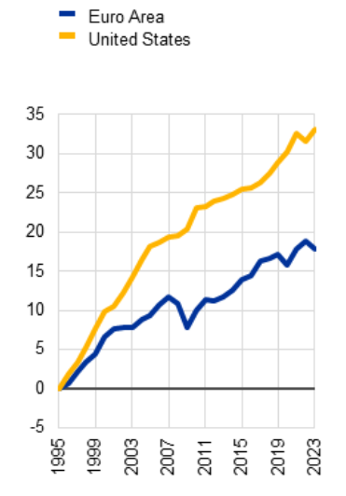
Source: ECB Financial Stability Review, November 2024
The terms and composition of bank lending contribute to shaping the productive capacity of the economy. A key insight from the ECB’s working paper is that high-performing banks are not only more resilient but also more effective intermediators. The paper shows, using granular data from the euro area credit register and the pandemic shock, that banks with higher "edge" (that is, performance relative to a market-based benchmark) originate more credit, direct it towards more productive firms, and support to a greater extent firms’ investment.
Conversely, the literature on credit misallocation points to a significant risk: banks, especially during stress periods, often support non-viable firms instead of allowing resources to be reallocated. For instance, while public guarantees during the COVID-19 pandemic were vital for sustaining viable firms through temporary liquidity shocks, they inadvertently supported less productive businesses, depressing aggregate TFP. More broadly, the “zombie lending” witnessed in Japan and Europe after crises periods like the Global Financial Crisis underscores how misallocation can severely drag down long-term competitiveness.
The capacity of a financial sector to support innovation is another critical dimension of the productivity-finance nexus, and banks are, by nature, not best placed to finance early-stage or innovation-intensive firms whose assets are predominantly intangible and whose cash flows are uncertain. This is because banks, and creditors more generally, are only interested in their credit being repaid and do not participate to the profits of a company and therefore may lack incentives and skills to screen for particularly innovative and productive ventures. The incentives to screen for innovative and productive firms and invest in those are greater for equity investors, which take part to the ownership of a company and to the profits it may generate. In other words, equity investors, differently from bank investors, participate to the upside risk of a company and have a different risk/reward profile than banks. Banks also normally opt for investments into tangible assets, which can be collateralised to help mitigate credit risk. Given innovative firms’ uncertain and often intangible and uncertain valuation aspect, for instance linked to intellectual property rights, these loans cannot be collateralised in a way that grants a more favourable capital treatment, and are hence less interesting for banks. Spotting opportunities with early-stage firms requires specific skills that are less present in banks and more in equity investors (e.g. venture capital firms). These structural limitations of bank-based intermediation argue for a more diversified financial ecosystem, with a greater share of equity and venture capital investors, a conclusion that points directly to the rationale of the Savings and Investments Union strategy.
While banks are the primary source of external financing for the majority of European firms, and particularly for SMEs, the efficiency of capital allocation (i.e. the degree to which credit flows to firms with the highest marginal productivity of capital) may not be the (main) objective of bank lending. At the sectoral level, the composition of bank lending portfolios across the euro area reveals significant concentration in real estate. A substantial share of bank credit in most European countries is directed to the real estate sector, both residential mortgage lending and commercial property financing. While such lending is economically important, it is equally important that bank credit in collateral-backed real estate is complemented by the financing of innovative, fast-growing firms, which should also rely on other sources like equity investors. Furthermore, a large real estate banking portfolio may impact housing availability.

    - Banks as market intermediaries
Beyond their traditional role as deposit-taker and lenders, some banks serve as intermediaries in financial markets. In this capacity, they operate as underwriters, arrangers, dealers, custodians and risk managers, thereby enabling investment flows across the EU economy. This intermediary role is heavily concentrated around the seven euro-area global systemically important banks (G-SIBs) and other large EU banks.
Repo markets are one of the key channels through which banks’ intermediation operates, given the scale of these markets. Repo intermediation activity has more than doubled since 2021, driven by increased demand from non-euro area non-bank financial entities (NBFI). Repo intermediation in US dollar warrants particular attention in this context, considering the demand from non-euro area investment funds (mainly hedge funds) for short-term liquidity denominated in USD. This activity is highly concentrated within five euro area G-SIBs accounting for circa 80% of banks' total reverse repo claims on NBFI entities. Furthermore, these G-SIBs are also the principal repo counterparties for those NBFI entities on the liability side, making them simultaneously the largest lenders to, and borrowers from, the NBFI sector. This two-way exposure creates a structural interdependency as any stress event triggering outflows would simultaneously erode both the asset positions and the funding base of institutions at the core of the intermediation chain.
The G-SIB’s intermediation role has grown markedly relative to domestic activity, reflecting the sizeable international footprint of some euro area G-SIBs. Sustaining this intermediation role requires euro area G-SIBs to raise significant USD funding, with currently approximately 17% of funding denominated in US dollars. This funding is sourced predominantly from wholesale markets, making the G-SIBs’ intermediation capacity structurally contingent on continued access to these markets. Since the monetary policy tightening cycle began in 2022, total outstanding amounts of euro area banks’ US dollar repos have almost doubled, reaching EUR 1.6 trillion in November 2024, whereas euro-denominated repo volumes have remained broadly unchanged over the same period. Euro area banks are net US dollar borrowers in the repo market, with volumes of repos exceeding reverse repos by around EUR 250 billion, and they channel these dollars predominantly toward non-euro area non-banks. Beyond repos, euro area banks have also expanded sharply as net providers of FX swaps to euro area non-banks: net positions vis-à-vis euro area non-banks have tripled over five years, with net positions to investment funds increasing up to fivefold and to pension funds up to threefold since 2018. Unlike US banks (from which euro area G-SIBs are net buyers of US dollars) euro area banks thus serve as the structural intermediary redistributing dollar liquidity toward the European NBFI sector.
This concentration of dollar intermediation in a few G-SIBs creates mutually reinforcing vulnerabilities. On the liability side, the short-term nature of the funding on which these G-SIBs rely, approx. 60% of deposits and repos with NBFI entities, renders them structurally exposed to outflows. On the asset side, around 26% of total identifiable exposures to NBFI entities involve firms using leveraged strategies, with any deterioration in market conditions risking triggering simultaneous deleveraging by the counterparties providing that funding. These balance sheet risks are compounded by two structural features of the markets in which the intermediation takes place. First, both the repo and FX swap markets are highly concentrated, with the top four euro area dealers now accounting for about 60% of the FX swap market, up from 50% five years ago. The failure or retrenchment of even one G-SIB could impair the proper functioning of USD intermediation of the European financial system. Second, the off-balance sheet nature of the FX swap exposures limits the assessment of associated risks, especially concentration risk. Should these G-SIBs curtail their activity under stress, their counterparties could face difficulties funding or hedging dollar-denominated investments and may need to sell such assets, transmitting bank-level stress directly into broader asset price dislocations. These dislocations could be further amplified by the structural dependency of EU GSIBs on USD funding mechanism (including FX swap lines and USD money markets). This dependency weights on EU banks’ competitiveness as the cost of maintaining USD liquidity buffers disadvantages EU banks compared to US peers.
Next to servicing NBFIs, banks play a crucial role in the capital markets by channelling retail savings into diverse investment products, such as UCITS funds, ETFs, and pension schemes under applicable regulatory requirements. The top five EU-headquartered assets managers by assets under management are bank-affiliated, underscoring the impact of banks in the savings-to-investment pipeline.
As underwriters and lead arrangers, banks function as a gateway for corporates seeking capital markets access. Their influence is particularly pronounced in the publicly listed equity (EUR 87 billion in equity issuance, including IPO and secondary offerings in 2025), bond issuance (EUR 436 billion in corporate bond issuance in 2025 and EUR 3.2 trillion in new sovereign debt issuance in 2025), and in mergers and acquisitions (EUR 348 billion in deal value in 2025). There are signs of increasing competition on several areas of the market from non-bank financial institutions: however, comprehensive data and research on these aspects is not readily available.
As market makers, banks are indispensable, ensuring liquidity, price discovery and risk management across a range of financial instruments. The EU relies structurally more on its banking sector for market making compared to the US, rendering the operational capacity of EU banks’ trading desks systemically important.
As post-trade service providers, banks operate crucial services subsequent to the execution of trades, facilitating capital movement. Acting as settlement agents, clearing members, custodians and collateral managers, banks facilitate the seamless transfer of assets for EU counterparties.

  - Resilience, profitability and market valuations
The analysis of the banking sector’s competitiveness must rely on its overall resilience and sustainability in generating profits. Only banks that are stable and sound can be competitive and can—in turn—contribute to the competitiveness of the broader economy. The profitability and competitiveness of a bank is key to ensure its long-term viability and stability, as profits are the first source of capital for banks.
The EU banking sector is resilient, as shown by a series of indicators and as evidenced by the latest EU wide stress tests. Liquidity ratios are overall stable and satisfactorily above minimum requirements, with LCR and NSFR standing at 163% and 127%, respectively, as of Q4 2025. The results of the 2025 EU-wide stress test show that European banks remain resilient under an adverse scenario which combines increasing geopolitical and trade tensions, a severe EU and global recession and rising inflation – a very relevant scenario in the current geopolitical context. The CET1 ratio of participating banks stood at 15.8% on average at the beginning of the exercise, the highest starting point of all previous EBA stress test exercises. Despite the sizeable losses induced by the stress scenario, the average CET1 ratio at the end of the scenario was 12.1%. All 64 banks in the stress test sample remained above minimum capital requirements except one that breached the leverage requirements, while 17 banks faced limits in their dividends’ distribution – hitting “the MDA trigger”. The results of the stress test underpinning the resilience of EU banks to the adverse stress scenario can be explained by three key factors: the solid capital position, the strong ability to generate income and profitability, and the good asset quality.
The banking turmoil of spring 2023 in the United States and Switzerland was a real-life stress test that proved the resilience of the EU banking sector in a moment of heightened market tensions. In Spring 2023, Silicon Valley Bank and three other US banks failed in succession. These events created tensions in financial markets that went beyond the US banking sector. Credit Suisse also experienced a fatal loss of market confidence that brought its collapse and government sponsored acquisition by UBS. Notwithstanding the heightened tensions in financial markets, following this series of bank failures is a complex macro-financial environment, the EU banking sector proved resilient as no EU bank entered into difficulties. EU public authorities had monitored any arising issues and communicated at key junctures of the banking turmoil.
    - Capital increase and asset quality strengthening
Today, EU banks are stable and well capitalised: their capital ratios are at all-time highs and have almost doubled compared to 2009 and increased by 30% compared to 2014 levels. In the first years following the GFC, EU banks made efforts to shore up their capital ratios by improving capital supply and asset quality. The decade from 2014 to 2025 confirms a trend of a remarkable capital build-up from the context of vulnerable post-crisis base to levels that guarantee resilience of the sector. Looking at Tier 1 capital ratio, EU banks’ Tier 1 ratio at Q4 2025 stood on average at 17%, increased by 400 bps from the 2014 level of 13%, and by 755 bps from the 2009 level of 10%. The picture is similar when looking at the CET 1 ratio, now at 16,3% and increased by 400 bps and 730 bps from its 2014 and 2009 levels, and at total capital ratio (which considers also Additional Tier 1 and Tier 2 instruments), which stands today at 20,4% and was 16,2% in 2014 and 13% in 2009.
The capital increase in EU banks was encouraged by a demanding regulatory framework and supervisory conservativeness which led to a continuous build-up over time, coming from equity issuances and retained earnings. EU banks’ capital supply, looking both at CET 1, Tier 1 and total capital, increased from 2010 onwards. The capital buildup is the result of supervisory pressures and EU banks’ ability to shore up their solvency profiles coming out of the GFC. Analysing the composition of the capital build since 2009, in the first half of the 2010s, capital accumulation was primarily driven by issuance and the injection of fresh capital in the system via equity raises and issuance of contingent convertible hybrid instruments. The process took time and efforts, constrained by chronically low profitability and investor scepticism about European bank valuations.
The 2010s decade also featured waves of deleveraging and derisking that contributed substantially to the increase in capital ratios, even though at the cost of exits from certain activities and markets, including cutting cross-border activities. Over the first years of crisis, deleveraging had largely been driven by equity increases – as banks located in the euro area issued EUR 133 billion in quoted shares from December 2008 to March 2013, while assets remained close to 2008 levels. From May 2012 to 2014, EU banks reduced their consolidated balance sheets by over EUR 5 trillion (of which EUR 4,3 trillion of euro area assets), with great variation across banks. Around half of this decline came from a reduction in derivative positions, which has made the most significant contribution to balance sheet shrinkage on aggregate. The second driving factor was a reduction in loans to the non-financial private sector (including asset transfers) specifically affecting countries under macro financial stress. Contextual to the deleveraging, EU banks were faced with a deterioration of asset quality. In countries worse hit by the crisis, non-performing loans (NPL) ratios were increasing to all-time highs to the peaks of 2013-2014. Following deleveraging and balance sheet derisking efforts, in the years between 2014 and 2018 EU banks gradually reduced their stock of NPLs and exited lines of business that either were perceived as excessively risky or were not profitable enough – hence not generating enough risk-adjusted capital.
Figure 8 - CET 1 ratio of EU banks, SSM sample (as of 2015) and EU G-SIBs (changing composition). CET 1 capital for years before 2013 refers to Tier 1 capital excluding hybrid instruments.
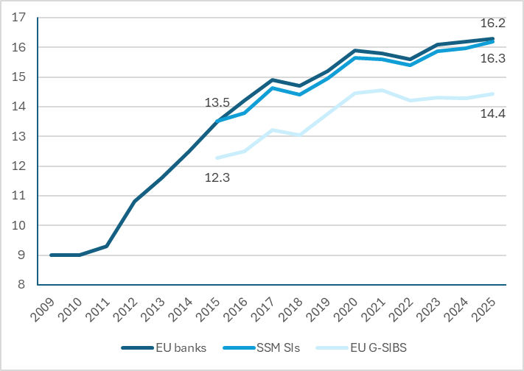
Source: ECB, EBA

Over the past 10 years, EU banks have improved their asset quality. In 2014, NPLs were a macro-financial problem and a drag on the EU banking sector, with the non-performing loans amounting to 6,5% of the total loans and advances (the so-called NPL ratio) – see Figure 9. On the back of the balance sheet derisking efforts and the improved internal capacity of banks to manage impaired assets, the picture is much different today. The NPL ratio remained stable at 1,8% as of Q4 2025 and the EU banking sector has proven able to weather the COVID crisis, the inflation spike and the energy crisis maintaining a high credit quality. Looking at the credit risk in banks’ portfolios, the picture looks broadly under control even though Stage 2 loans (i.e. underperforming loans according to IFRS 9) have increased over the past 5 years (from 8% to 9,5%) and vulnerabilities may arise from an uncertain macroeconomic and geopolitical outlook.
Figure 9 - Non-performing loans in the EU
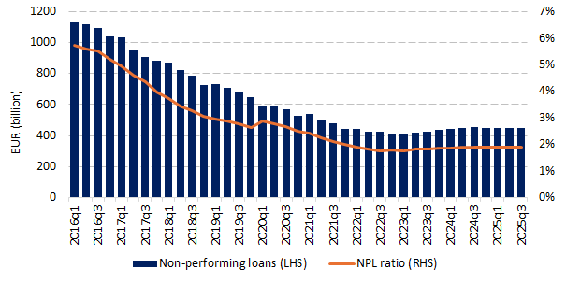
Source: ECB.
Note: Non-performing loans, domestic and (non-EU) foreign subsidiaries and branches, FINREP reporters in EUR (billion) and NPL ratio, domestic and (non-EU) foreign subsidiaries and branches, FINREP reporters, EU, quarterly data.

    - Profitability improvements
In addition to being well capitalised and resilient, today’s EU banking sector is profitable – yet, financial market valuations are still treating EU banks at a discount compared to past performances and to US peers. Since the GFC, the sector has struggled to recover and has recorded years of low profitability, linked to both macro-financial and idiosyncratic factors. In the years between the GFC and euro area sovereign debt crisis and until 2016, EU banks had a return on equity (RoE) between 3% and 4%. In the years between 2017 and 2021, the RoE of the EU banking sector was around 6%, with the exception of 2020 where it stood at 0.5% due to the increase in loan-loss provisions resulting from the COVID pandemic. All along these years, the RoE of EU’s banking sector was below its cost of equity – meaning that EU banks were delivering to their investors less than their expected rate of return. Today (as of Q4 2025), the RoE of EU banks stands at 10.5%, which is in line with the performance of 2024 and 2023 (10.5% and 10.4%, respectively). Hence, EU banks’ profitability is at record highs, with earnings surpassing pre-2008 financial crisis peaks.
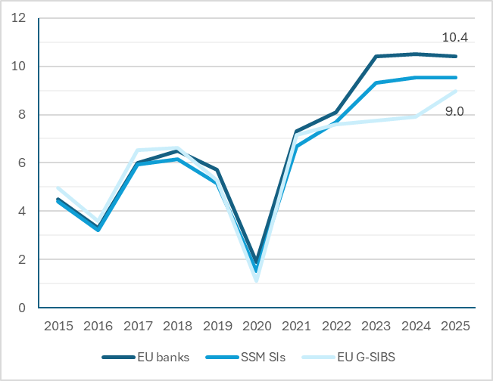 | Figure 10 – Return on equity (in percentage points) of EU banks, SSM Sis and EU G-SIBs.  Source: ECB, EBA
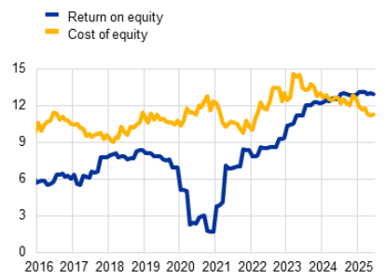 | Figure 11 – Return on equity and cost of equity (in percentage points) of listed euro area banks. The cost of equity of euro area banks is estimated based on Altavilla et al (2021).  Source: ECB

Interest income dynamics
The trajectory of net interest income (NII) over the past three years (2022 to 2025) has been the dominant driver of the remarkable improvement in EU banks’ profitability. Net interest income is a key component of EU banks’ revenue structure as it accounts for 50% to 60% of the EU banking sector’s total income. As a response to the inflation spike that took off at the end 2021, the ECB (together with other EU central banks) rapidly increased its key interest rates in the attempt to tame inflation. The monetary policy tightening cycle that began in 2022 delivered a substantial boost to NII, as lending rates repriced upward faster than deposit remuneration, enhancing EU banks’ net interest margin – see Figure 12. Looking in detail, the enhancement of interest margin can be observed driving the increase in NII since the start of 2022, as the banking sector was anticipating a monetary policy tightening that started in July 2022.
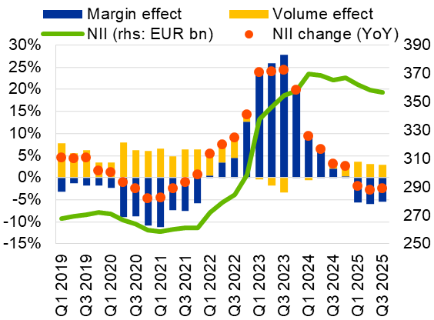 | Figure 12 - Net interest income (NII) dynamics.  Source: ECB and Supervisory Reporting

EU banks’ net interest margins benefited from a quick pass-through on interest earning assets and on a favourable outlook to keep their financing expenses under control. In particular, in 2022, the average loan-deposit spread on the front book (i.e. the new loans granted by a bank) started increasing, tripling from 1,5% to more than 4% in 2023 – see Figure 13. In addition, banks benefitted from favourable financing conditions, keeping under control their interest expenses. On financial markets, banks’ cost of capital decreased as yields have continued to decline and credit spreads compressed to the lowest level since the start of the hiking cycle (with the exception of covered bonds), particularly tight for the most junior instruments – see Figure 14. On the deposits side, EU banks have seen inflows of deposits over the past 3 years, with the exception of the second half of 2023: the trend extended further a relatively cheap financing source, showing on one hand a rather low sensitivity of deposit rates to policy interest rates – see Figure 15 – though, on the other hand, a noticeable share of depositors shifted from non-remunerated overnight deposits to remunerated term deposits.
Figure 13 – EU Banks loan-deposit spreads on outstanding amounts (in blue) and on new business (in yellow); and net interest margin (in blue).  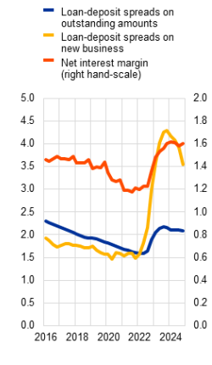 | Figure 14 – Secondary bond markets bond yields and spreads of euro area banks.  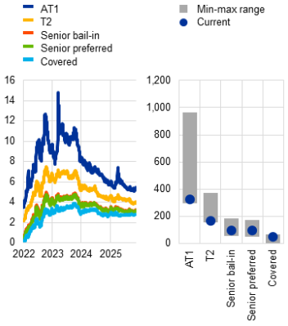
Source: ECB | Source: ECB  Note: left hand chart in percentages; right hand chart in basis points

Figure 15 – Deposits and passthrough rates.
Panel a) Quarterly deposit flows and annual growth; Panel b) Deposit betas across past cycles; Panel c) average deposit rates offered by euro area banks
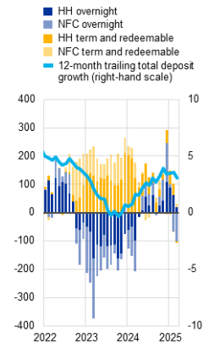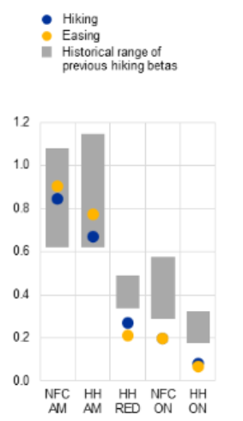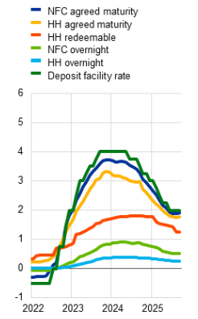
Notes. Panel a) January 2022 to March 2025; three month rolling flows, EUR billions, percentages.
Panel b) change in rate on new business divided by change in the deposit facility rate, Deposit betas for the hiking cycle are calculated on the period from January 2022 to November 2023 for term and redeemable-at-notice deposits and from January 2022 to May 2024 for overnight deposits, reflecting the peak of different deposit rates. Easing betas for agreed maturity (AM)/redeemable-at-notice (RED) and for overnight (ON) deposits consider the period from November 2023 and May 2024 until September 2025 respectively. “Historical range of previous hiking betas” refers to the peak betas reached during previous hiking cycles in November 2000, November 2005 and September 2011.
Panel c) January 2022 to September 2025, percentages.
However, as the ECB (together with other EU central banks) began cutting rates from mid-2024, the NII tailwind has started to fade. Net interest margins started tightening, with EU/EEA banks posting a Net Interest Marin (NIM) of 1,58% in Q3 2025, down from 1,68% a year earlier, pushing net interest income to levels last observed in late 2023. Despite this headwind, overall profitability has held up reasonably well, supported by volume effects. European banks maintained robust return on equity levels averaging close to 10% in the first half of 2025, albeit with some cross-country variation.
Looking back at the previous decade, we observe a picture of chronic NII compression that was affecting the long run viability (and market valuations) of the sector. With the ECB's deposit facility rate at the zero lower bound or even in negative territory and the yield curve exceptionally flat, low bank profitability was driven by three distinct factors: weak income generating capacity, a legacy NPL problem and structural inefficiencies. At the time, 75% of euro area significant institutions were generating a RoE of below 8%. While banks benefited from loan volume growth (volume effect) and declining credit costs under those conditions, these positive effects were insufficient to offset the steady erosion of net interest margins as assets repriced downward at a faster pace than liabilities.
Non-interest income dynamics
The trend on non-interest income, notably net fees and commission income (NFCI) and net trading income (NTI), tells a different story from the NII path. Where NII was subject to a squeeze in the low interest rate environment, followed by a surge from 2022, non-interest income followed a more complex trajectory: a modest but significant structural rise until beyond 30% of total income in 2020 and 2021 as banks tried to diversify away from rate-sensitive revenues, followed by a partial displacement effect as NII resurged.
The evidence after the GFC and until the end of the last decade points to a weakly positive correlation between NII growth and NFCI growth for most SSM significant institutions, suggesting some degree of complementarity between these two income sources rather than substitution. In view of the pressures on net interest margins due to the prolonged period of low yields, many banks have sought to expand NFCI-generating activities to compensate for the slowdown in NII. However, the relationship between the two income streams actually linked them to cyclical factors and did not suggest a pure substitution effect. This complementarity suggested that both income streams were driven by common macro factors such as economic growth and lending volumes, meaning that in a downturn—precisely when banks would most need fee income to compensate for NII pressure—fee income would also tend to fall. In addition, there is no unlimited pool of fees available for all banks, and a substantial share of this stream of income is only available for a subset of business models like investment and custodian banks.
In 2021, as pandemic conditions eased and economic activity rebounded, profitability improved strongly driven by contracting cost of risk, as well as rising NFCI and NTI. Fee and trading income therefore served as an early-cycle recovery driver before NII had begun to benefit from the rising interest rates.
The onset of rate tightening from mid-2022 brought a sharp compositional reversal. As NII surged on the back of repricing, its share of total income rose sensibly, mechanically compressing the relative contribution of fees. Throughout 2022 and 2023, the share of net fee and commission income in total net operating income dropped, not because the absolute level of fees was collapsing, but because NII was growing far faster.
Figure 16: Net operating income drivers and cost efficiency for EA and US G-SIBs
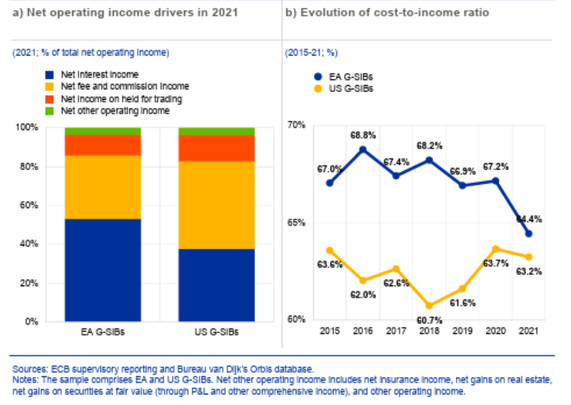
Source: ECB
Efficiency and cost-income ratio
Analysing today’s levels of profitability, EU banks have strengthened their income generation and have become slightly more cost-efficient over the past 10 years. The dynamics of the cost-income ratio (CIR), which has decreased from 63% in 2014 to 53,3% in 2025, capture the cost discipline showed by banks especially after COVID, and is also reflective of the strong increase in income generation. While the increase in profitability has already been discussed, to ascertain whether EU banks have also increased their cost effectiveness focus on operating costs as a share of core assets and liabilities. European lenders show a structural reduction in costs between 2021 and 2024 that hints to an increase in operating efficiency.
Looking back at the period until 2020, the high cost-to-income ratio (CIR) was a recurring and prominent problem for the EU banking sector, which ended up becoming a structural issue. The problem was fundamentally one of income (the denominator) stagnation rather than costs (the numerator) excess. Banks were attempting to reduce operational costs through branch network rationalisation and headcount reductions or investing in digital transformation. Nonetheless, cost savings from branch rationalisation and staff layoffs were easily offset by the initial restructuring costs or the need to spend more on digital platforms changes. Yet, largely due to low income growth, EU banks' CIR on average remained above pre-crisis levels – see Figure 17.
Figure 17 – Cost income ratios of euro area banks
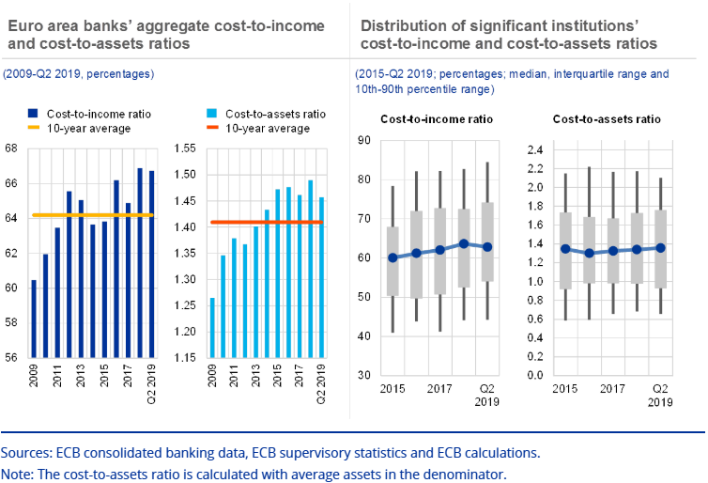
Source: ECB consolidated banking data
After years of flat CIR dynamics, the combination of post-pandemic revenue recovery and continued cost discipline began to shift the ratio more favourably from 2021 onwards. Supported by higher interest rates and low loan loss provisions, euro area banks showed robust earnings momentum throughout 2022—this was particularly true for banks in countries where variable-rate lending predominated. The income denominator of the CIR was finally expanding, which mechanically improved the ratio even where costs were broadly stable. In 2022, bank operating profitability improved further, though the outlook had become more uncertain amid vulnerabilities in non-financial sectors.
From 2023 onwards, the CIR narrative shifted from a story of persistent failure to one of genuine but incomplete improvement. The ECB’s 2025 SREP results (covering the 2024 performance year) provided quantitative evidence of the post-2022 efficiency transformation across the EU banking sector – see Figure 18. Looking across business models, the CIR trend hinting to operating expenses growing at a slower pace than operating income, demonstrating cost discipline, especially for G-SIBs, retail and consumer credit lenders, and universal and investment banks.
Figure 18 - CIR by business model
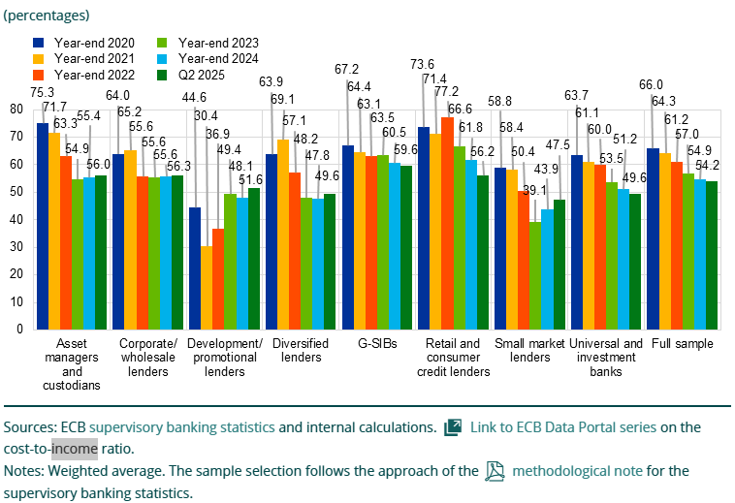
Source: ECB, 2025 SREP results
Analysing the dynamics of CIR across the period, a structural tension emerges clearly and consistently. The CIR has improved dramatically since 2022, and the tangible improvement is the result of efforts from banks and supervisors. However, this positive development arguably does not constitute a structural cost cut, and it is instead attributable to income growth driven by the rate cycle — a cyclical rather than structural driver. This distinction — between income-driven CIR improvement and genuine structural efficiency gains through cost reduction — is central to look prospectively and steer the discussion under the policy, (supervisory) and banking business points of view. The concern is that as the NII tailwind fades, banks that failed to use the high-profitability window to fundamentally restructure their business, consolidate or restructure the cost bases may find the CIR drifting back toward the elevated levels that defined the 2014–2021 era.
    - Market perception and valuations
Market valuations of EU banks have improved compared to the previous decade but still trade at a discount compared to the pre-crisis context and to international peers. Prior to the GFC, the long run weighted average of EU banks’ price to book ratios was around 2x, with US banks already showing a premium at 2.4x. After the GFC and during the euro sovereign crisis, EU banks have traded below parity, meaning investors priced the net assets of EU banks at a discount compared to their book value. For more than a decade, the low valuations reflected the many issues that were affecting EU banks’ performances and perceived solidity, as well as macro-financial factors. Today’s price-to-book ratio of EU banks (considering a composite index of publicly traded banks) have surpassed the parity, which is a positive outcome, even though it is still far from the pre-GFC long run average. In addition, today’s level still implies EU banks are traded at a discount: both compared to US banks, even though the gap has somewhat closed compared to the last decade, and compared to their own performance in the pre-GFC period. Anecdotally, the order of magnitude of the decline in EU banks’ valuations (and the contextual increase of US banks’ ones) over the past 25 years is remarkable: at the beginning of the 2000s, the 5 largest EU banks had individually a market capitalisation higher than the largest US bank; today, the single largest US bank has a market capitalisation higher than the 5 largest EU banks, combined.
Figure 19 – Price to book ratios of indices of EU banks and US banks. The perceived lack of competitiveness of EU banks vs their own pre-crisis performance (PB ratio used to be 1.8x before the GFC and is now 1.4x), and vs US banks’ valuations at 1.6x.
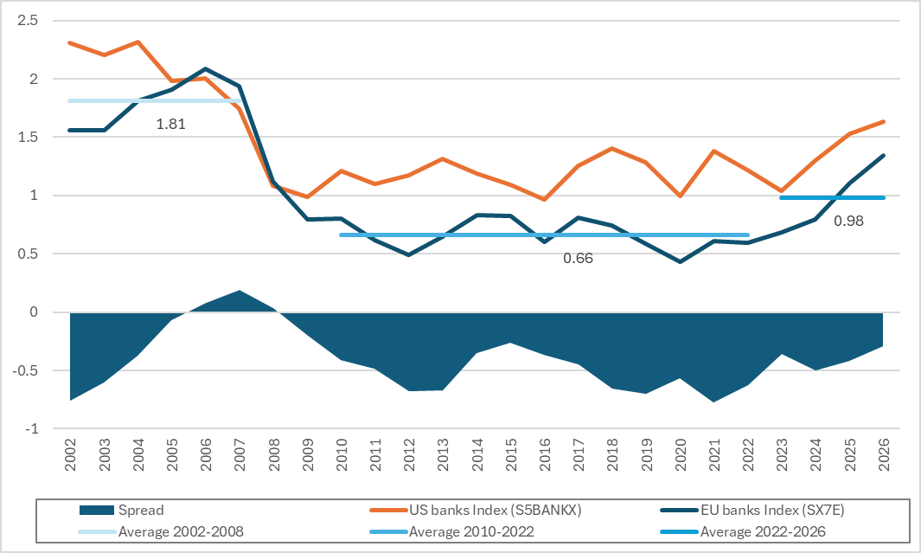
Source: Bloomberg, DG FISMA calculations
Market prices of EU banks can be seen as driven by a mix of variables, notably a bank’s profitability and how much of those profits it manages to distribute, its management and operational efficiency, and the macroeconomic outlook. According to an ECB analysis, low EU banks’ valuations after the GFC were driven mostly by the weak growth environment (until 2013) and subsequently (from 2013 onwards) by the faltering profitability profiles. Moreover, the study highlighted how asset quality, and management and operational efficiency were also explaining the dynamics of market prices. Overall, those factors explained about half of the variability of EU’s share price, meaning other factors were also playing a role.
One key element influencing market valuations is related to how much of its profits a bank manages to pay out to its investors – in terms of dividends and share buybacks – and investors’ future expectations around that. Effectively, the price of an equity depends not just on how profitable the company is, but also on the share of profit which is paid out or distributed. The ECB’s Financial Stability Review of November 2025 makes the link between listed EU banks’ share price and their expected profitability and payouts. Also, Resti at al. (2025) point out to the difference between the historical payout ratios between EU and US banks as a potential factor explaining EU’s share price underperformance.
Market valuations can be influenced by investors’ long-term expectations over the economy and the sector. Investors may still regard the increase in EU banks’ profitability as temporary, and cast doubts on the ability to maintain these performances consistently over time. In other words, investor sentiment towards the sector takes time to adjust and structural considerations play a factor. Heider et al (2025) interpret the stickiness of market valuations of EU banks as linked to the fragmentation of the single market, which does not give EU banks a sufficiently wide market to guarantee continuous growth and profitability over time. In addition, analysts report that the past decade of low M&A activity, coupled with government interventions that hindered recent cases, dissipated investors interest in the sector.
In addition to these explanations, several studies tried to determine the impact of regulation on banks’ valuations. A study by Oliver Wyman (2023) analyses the impact of regulatory burden on EU banks compared to US peers, concluding that the incremental regulatory impact on EU banks amounts to 0.8-1.0 percentage points in RoE and translates into a 0.11-0.12 on their price-to-book ratio. The analysis mostly aims at showcasing how the EU regulatory framework puts European banks on an unlevel playing field with US ones. Other analyses contradict the claim of that study, and actually flip the argument by indicating how the US framework would be more stringent than the EU’s one. Investors are interested in comparative analyses on levels of capital requirements across jurisdictions, but are even more so interested looking ahead at changes (decreases or increases) of the regulatory framework imposing those capital requirements. Overall, the main takeaway from the debate is that regulatory framework can be a factor in influencing a bank’s business choices, and possibly that the prudential framework is adapted to the realities of its own banking sector.
One additional factor explaining EU banks (and more broadly EU equities) valuation dynamics is the size of the stock market. In the 2000 the market capitalisation of US domestic listed stocks was USD 15 trillion, while the EU’s was USD 5 trillion. Today, the market cap of US companies has increased by 5 times to USD 75 trillion, while EU’s market cap has increased by 2.7x to USD 13.6 trillion. While the dimension of the stock market does not per se explain differences in market valuations of single stocks, the orders of magnitude can help understand the scale at which the US stock markets have grown and how big of a problem the EU has without a completed SIU. This also has a remarkable effect on the CIB activities as it prevents EU banks to leverage on a wide EU market as their basis to develop scale and global operations.

- REMAINING CHALLENGES
  - Fragmentation of the single market in banking – Main issues
The fragmentation of the banking single market is a strategic vulnerability with detrimental effects on the EU financial sector and the EU economy. A more integrated financial market would enhance the EU's collective resilience to idiosyncratic shocks by enabling genuine cross-border risk sharing and portfolio diversification. In a fully integrated market, banks could allocate capital across Member States, so that a downturn in one country is partially absorbed by income flows from others. Where national segmentation persists, this insurance mechanism based on the private financial sector is absent, and the counterbalance of idiosyncratic shock relies on the public sector: losses concentrate domestically, amplifying the severity of local downturns and increasing the likelihood that single Member States’ financial systems come under stress simultaneously rather than acting as buffers for one another. Under the EU economy’s perspective, fragmentation reduces competition and hinders access to finance for businesses and households. This means that the cost and availability of capital continue to differ markedly across Member States, reflecting structural barriers, including the regulatory ones, rather than genuine differences in creditworthiness or investment risk.
The persistence of national fragmentation imposes on EU banks significant structural costs and prevents them from achieving economies of scale and scope. Cross-border banking activity within the EU remains far below what the size of the internal market would warrant, in part because regulatory and supervisory heterogeneity, national ring-fencing requirements and differences in insolvency frameworks create barriers to entry and to further deepen cross-MS activities. Without the ability to consolidate operations and client relationships across borders, European banks are unable to achieve the cost efficiencies that larger, more geographically diversified institutions realise through the sharing of fixed infrastructure, technology platforms, compliance functions and risk management capabilities. This penalises European banks, weakening their competitive position, eroding their capacity to invest in digital transformation, and ultimately reducing the quality and breadth of financial services they can offer to European businesses and households.
    - Evidence of a fragmented banking sector
Data from the EBA show that EU banks have slightly more cross-border exposures outside the EU than in another Member State, reflecting the shortcomings of the EU Single Market for banking. As expected, the majority of EU banks’ lending is concentrated in the Member State where the bank is established: this represents ca. 56% of EU banks’ total exposures. Looking at the cross-border exposures, EU banks have around 22% of exposures outside the EU and around 21% of exposures within the EU. While on one hand this can reflect the global reach of some large EU banking groups or their presence in neighbouring third countries, on the other hand the analysis highlights that a bank expansion beyond its Member State of incorporation finds similar barriers in other Member States vis-à-vis its expansion to third countries.
Looking at the trend over the years, integration of banking markets has somewhat increased, but remains at unsatisfactory levels. Looking broadly at financial integration, the picture over the last 15 years is one of a slow-paced integration and some episodes of retrenchment, where banks withdrew back to their national markets. The ECB response to the targeted consultation depicted a context of integration mostly limited to the wholesale banking, where 22% of total lending there happens on a cross-border basis. Cross-border lending in the euro area to all sectors except the banking one (i.e. households, corporates, NBFIs, and governments) represented 8% of total lending. For the corporate sector specifically, granular analysis shows that as of the fourth quarter of 2025 cross-border lending within the euro area represented ca. 16% of total corporate lending, of which 8% of indirect form – namely, where the subsidiaries of a bank and a borrower are domiciled in the same country, but (at least) one of their parents is domiciled in a different member.
Figure 20 – Cross border lending across the Euro Area
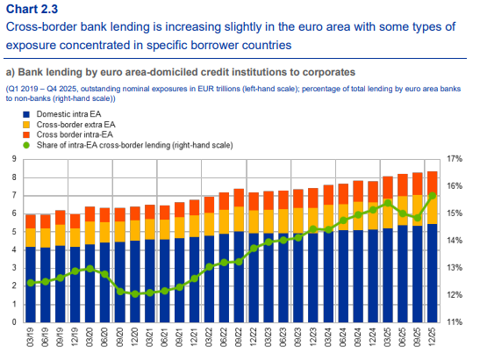
Source: ECB Response to the targeted consultation
EU banks face significant barriers that limit their movement of funds across Member States. The current fragmentation exemplifies the cost of an absence of a European dimension in the banking sector and the economic inefficiencies it generates. Several estimates confirm that there is a significant amount of capital and liquidity segregated in EU subsidiaries of EU banking groups. ECB Banking Supervision estimated that the transferability of EUR 230 billion of high-quality liquid assets within groups across Member States is constrained by the application of full liquidity requirements at Member State level. This is a conservative estimate, as EUR 150 billion of excess high quality liquid assets are also held within those subsidiaries and some of those may not be transferable because of other requirements like large exposure limits, individual level requirements, etc. In a recent study, AFME estimated a similar amount, EUR 250 billion of liquidity, to be “trapped” in subsidiaries of EU banking groups. In a similar fashion, AFME estimated EUR 225 billion of capital to be constrained within EU subsidiaries of EU banking groups.
These barriers act like de facto tariffs and do not allow EU banks to reap the benefits of being in the single market. According to the ECB, despite the decrease recorded between 2005 and 2023, intra-EU service trade costs, including in the financial sector, are roughly equivalent on average to an ad valorem tariff of around 95% compared to domestic trade. Also, a recent IMF report recognised that requirements at national level corresponded to internal EU tariffs amounting to up to 100% for trade in financial services.
In a study released in June 2026, the IMF concluded that bank credit in the EU is strongly biased towards domestic borrowers. The IMF estimates that cross-border lending to NFC corporates by immediate lenders represents on average 5% of all NFC lending in EU with sizeable variation, ranging from 2% (IT) to 49% (IE). Cross-border lending by parent entity via subsidiaries or branches represents on average only around 14% of total NFC loan volume, with large variations notably in Central and Eastern European Member States where the share of lending via group entities is higher. The analysis by the IMF highlights significant barriers to entry in cross-border lending, including policy aspects like bank regulation, financial safety nets, but also non-prudential barriers like divergences in national insolvency laws and taxation. The IMF estimates that reforms reducing barriers to cross-border banking could raise EU GDP by about 2 percent in the long term, with pronounced benefits especially for start-ups.
The status quo creates hurdles for banks to explore cross-border business within the EU, as witnessed by the trends in the concentration metrics and mergers and acquisitions dynamics. As AFME reports, M&A activity has declined compared to the first decade of the 2000s, dropping from over 100 operations to about 20. In addition, most M&A occurs within Member States. The decrease of M&A activity tells a twofold story: first, the EU banking sector becomes less attractive for investors; second, cross border M&A activity becomes less attractive – and this is visible in the decrease of cross border M&A activity. In sum, euro area banking sector consolidated at national level but not at EU or euro area level, not allowing banks to attain the benefits of the single market and economies of scale within it.
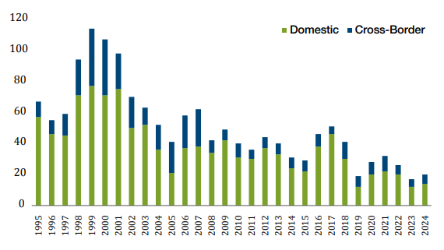 | Figure 21 - Number of M&A banking deals between BU banks  Source: AFME, Dealogic
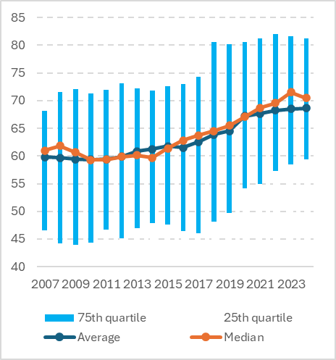 | Figure 22 - Share of the 5 largest credit institutions in total assets per each member state. Interquartile ranges in blue and medians are calculated across average country values. Data for each Member State are available from 1999 or from the year of EU accession.  (Data 2007-2024)  Source: ECB Data, FISMA Calculations

    - Fragmentation and chronic lack of scale
Large banks in general benefit from economies of scale, lower average costs, greater diversification, and enhanced capacity to invest in technology and risk management that allow them to operate more efficiently and extend credit at finer margins. Using data across EU countries, the ECB constructed a composite indicator of banking sector overcapacity encompassing sector size, competition, and efficiency and tracking its evolution from the GFC. The findings show that overcapacities have generally declined since 2008, driven by deleveraging, rationalisation of branch networks, and technological substitution. However, significant cross-country heterogeneity persists, with some markets having been slower at consolidating. As shown in Figure 22, EU banks have undergone in the past years a consolidation within Member States borders. Such dynamic had the effect of increasing concentration within each MS, but failed to grant a single EU bank sufficient size to reap economies of scale within the Single Market. Looking at the five largest EU banks, and comparing with the five largest US banks, one can observe that the cumulative market share of the former group is 31%, while that of the latter stands at 45%. Anecdotally, the difference is stark when looking at the largest bank in each jurisdiction: in the EU, the market share of the largest bank is 8%, while in the US, the market share of the largest bank is twice as much.
Figure 23 - Comparison of market share of the 5 largest banks in EU and the US
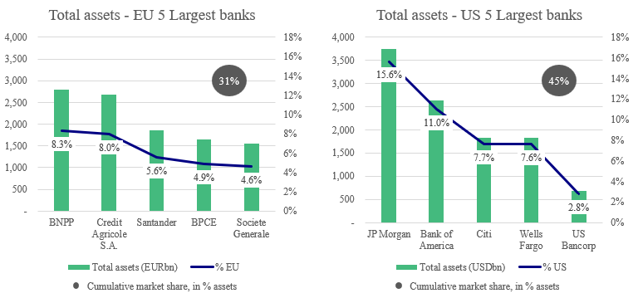
Source: ECB data, banks individual annual reports, FED data – (as of end 2025)
The chronic lack of scale of EU banks is limiting their ability to compete in specific market activities. EU banks have long established franchises in corporate and investment banking (CIB) activities, but they have struggled to keep stable market shares not only at global level, but also in EU financial markets. In particular, US banks have larger market shares in EMEA than the EU G-SIBs (40% vs 29%, respectively). Additionally, specific EU markets activities are dominated by US players e.g. fiduciary services, commodity trading, and to a lesser extent custody services and corporate finance (like M&A). League tables across Equity Capital Markets, Debt Capital Markets, and M&As confirm the picture of EU banks struggling to keep presence, even in the European market. In particular, EU banks are essentially absent from Global League Tables for M&A Advisory, rank #6 and #8 in Debt Capital Market and #10 in Equity Capital Market. In League Tables for European market, the situation remains grim for M&A Advisory and Equity Capital Markets. Only in the area of Debt Capital Markets EU banks manage to maintain a relevant market presence, with four banks in the top 10.

Table 1 - Merger and Acquisition Advisor Ranking – Financial Year 2025
Europe |  |  |  |  | Global
Rank | HQ | Advisor | Value $bn | # deals | Rank | HQ | Advisor
1 | US | Goldman Sachs | 565.1 | 204 | 1 | US | Goldman Sachs
2 | US | JPMorgan | 374 | 163 | 2 | US | JPMorgan
3 | US | Morgan Stanley | 338.6 | 123 | 3 | US | Morgan Stanley
4 | US | BofA Securities | 269.7 | 121 | 4 | US | BofA Securities
5 | US | Citi | 197.3 | 94 | 5 | US | Citi
6 | US | Lazard | 175.9 | 146 | 6 | US | Evercore Inc
7 | EU | Rothschild & Co | 166.8 | 328 | 7 | UK | Barclays
8 | EU | BNP Paribas | 145.6 | 116 | 8 | US | Centerview Partners
9 | CH | UBS | 140.4 | 103 | 9 | US | Wells Fargo
10 | UK | Barclays | 139.4 | 67 | 10 | CH | UBS
Source: Dealogic
Table 2 - Debt Capital Markets (DCM) Bookrunner Ranking
Europe |  |  |  |  | Global
Rank | HQ | Bookrunner | Value $bn | # deals | Rank | HQ | Bookrunner
1 | EU | BNP Paribas | 197.61 | 833 | 1 | US | JPMorgan
2 | US | JPMorgan | 163.84 | 645 | 2 | US | Citi
3 | EU | Deutsche Bank | 155.84 | 598 | 3 | US | BofA Securities
4 | UK | Barclays | 146.95 | 725 | 4 | US | Morgan Stanley
5 | US | Citi | 131.56 | 508 | 5 | UK | Barclays
6 | UK | HSBC | 126.88 | 507 | 6 | EU | BNP Paribas
7 | EU | Credit Agricole CIB | 126.03 | 520 | 7 | US | Goldman Sachs
8 | US | BofA Securities | 124.33 | 505 | 8 | EU | Deutsche Bank
9 | US | Morgan Stanley | 107.1 | 400 | 9 | US | Wells Fargo
10 | EU | SocGen CIB | 102.26 | 400 | 10 | UK | HSBC
 |  | Subtotal | 1,382.40 | 3,097 |  |  | Subtotal
 |  | Total | 2,826.10 | 5,689 |  |  | Total
Source: Dealogic
Table 3 - Equity Capital Markets (ECM) Bookrunner Ranking
Europe |  |  |  |  | Global
Rank | HQ | Bookrunner | Value $bn | # deals | Rank | HQ | Bookrunner
1 | US | Goldman Sachs | 16.19 | 65 | 1 | US | JPMorgan
2 | US | JPMorgan | 12.67 | 51 | 2 | US | Morgan Stanley
3 | US | Morgan Stanley | 12.59 | 49 | 3 | US | Goldman Sachs
4 | EU | BNP Paribas | 11.99 | 79 | 4 | US | BofA Securities
5 | US | BofA Securities | 10.9 | 50 | 5 | US | Citi
6 | US | Citi | 7.17 | 52 | 6 | CH | UBS
7 | CH | UBS | 6.38 | 44 | 7 | US | Jefferies LLC
8 | UK | Barclays | 4.97 | 28 | 8 | UK | Barclays
9 | EU | Deutsche Bank | 4.35 | 34 | 9 | US | Cantor Fitzgerald & Co
10 | US | Jefferies LLC | 3.57 | 34 | 10 | EU | BNP Paribas
 |  | Subtotal | 90.79 | 220 |  |  | Subtotal
 |  | Total | 134.37 | 975 |  |  | Total
Source: Dealogic
These activities critically depend on size, which allows to withstand the instability of the business revenues, diversifying income across CIB activities in bad years and capitalising on excess demand in good years. A diversified market presence across corporate and investment banking can help banks stabilise the swings in revenues across business lines, driven by the instability of macro trends determining the fee pool that banks can earn. Growth rates in the Global Markets (GM) and Investment Banking (IB) sectors over the past 10 years have ranged from -37% to 27% with particularly pronounced swings during the pandemic. A bank of larger size can reap the benefits of diversification, offsetting between different activity types—both within GM, but also across GM and IB. Specifically, high volatility levels drive market making (to the benefits of GM business) at the expense of IB products, like structured deals and financing that tend to be postponed in period of high volatility. Vice versa, relative stability or anticipation of large shifts are conducive to (re)financing demand and larger undertakings. Furthermore, in this context big players like US banks will be better positioned to provide excess supply of CIB services/products when the market rebounds after a bad year.
Bigger banks are also better positioned to maintain broad coverage across different business lines, have better capacity to attract and retain talent. The global reach and capacity to maintain coverage throughout the cycle, coupled with capacity to commit financial and human resources, give non-EU banks a competitive advantage, acting as "one stop shops". Maintaining the broad presence comes with the trade-off of sustaining costly networks of highly specialised bankers to ensure market coverage, and by contrast allows higher revenues and attracts bigger and more lucrative deals. At the same time, bigger banks are able to offer more competitive remuneration packages to its bankers, which are a key component in corporate and investment banking activities.
In addition, CIB activities require investments in IT infrastructure to remain sustainable and gain the edge over the competition, and for some specific activities, like credit trading, a substantial initial investment is needed to enter the market. On one hand, the relatively small scale of EU banks does not allow them to mobilise the large resources needed to carry out the necessary investments; on the other hand, EU G-SIBs are also investing less in their IT infrastructure than their US competitors. In the three years 2019 to 2022, the average annual budget for IT investments of the largest US G-SIBs was around 0.5% of total assets, compared to less than 0.2% for EU G-SIBs – see also Figure 24. For instance, SSM analysis for 2024 looking at data published by the top four banks in the US and the EU shows that the top four US banks’ IT budgets are in absolute terms and relative terms higher than the budgets of the largest four EU banks.
Figure 24 - U.S. and euro area G-SIBs annual IT budgets, 2019-2022
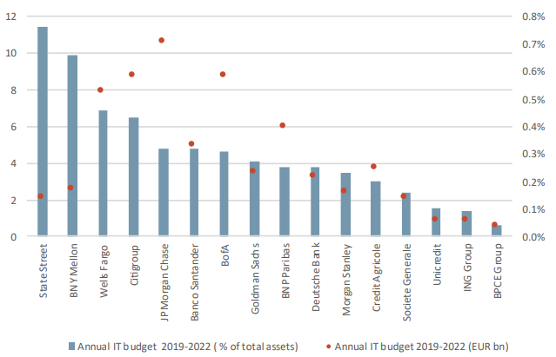
Source: EBA presentation at Workshop “Economic of the Single Market” (19 September 2025). ECB and EBA calculations. ECB Occasional Paper “Understanding the profitability gap between euro area and US G-SIBs”

CIB activities are important not just to the banks themselves, but also for financial markets and the economy. These activities can offer banks a source of revenues that is detached from the interest rate cycle and often provide group-wide services to the bank (like hedging and asset liability management for the bank’s treasury). Moreover, CIB activities expand the product offering to corporate clients, including other financial intermediaries and non-financial corporations. For instance, banks offer CIB services to insurance companies hedging risks they are not willing to cover and offer large corporations solutions to hedge e.g. interest rate or foreign exchange risks and may be the channel for those corporations to tap capital market financing, e.g. raising equity or issuing bonds. In this vein, a bank’s CIB activities are deeply intertwined with the depth and breadth of financial markets players and vivacity. US banks have global franchises also because they can leverage on well-developed US financial markets, whereas the lack of an integrated market for banking deprives EU banks from solid fundaments from which to develop their CIB activities. Therefore, facilitating CIB activities of EU banks also contributes to resilience and EU sovereignty.

    - Opportunities and challenges from market integration
Market integration is a central part of the policy response set out in the Communication and is the element with potential to deliver the biggest improvements to competitiveness. Integration can take various forms, including structural consolidation, shared infrastructures and operating models or direct provision of cross-border services. The lack of market integration derives from a multitude of factors, including the composite nature of banking rules, European and national, the result of prudential and non-prudential barriers, or political and economic pressure within Member States.
Benefits of cross-border market integration
Diversification makes banks more resilient to country-specific shocks. The diversification gains are greater the more different the markets are. Diversification and integration also contribute to better risk-sharing, smoothen local shocks and can also support effective transmission of monetary policy.
Scale effects allow banks to make efficiency gains and support their profitability, in particular thanks to the cost savings that derive from the central management of resources such as liquidity and capital, and potentially from more competitive funding rates on financial markets. Scale is also important to keep the pace in the current context of rising technology and cyber security. However, these benefits may not always be fully realised in practice, due to organisational complexities for certain business models in large cross-border banks, legal and compliance burden, different cultures, and other barriers. Benefits may depend on market segments and the business models of institutions.
The presence of foreign banks increases competition with domestic banks. Foreign-controlled entities were slightly more profitable than domestic banking groups in most Member States until 2021/22 when profits started to increase as a consequence of higher interest rates, consistent with research that found that foreign subsidiaries are more cost-efficient than domestic entities. This effect can be expected to be stronger for third country branches that were not subject to any capital and/or liquidity requirements.
Cross-border integration can also bring a more diversified offer, with more competitive pricing, of banking products to businesses and citizens, including local and internationally active clients. By preventing financial exclusion, unrelated to creditworthiness but linked to geographical factors, market integration can also improve the trust of citizens in the financial sector, and boost interoperability, consumer experience, or accessibility and treatment of data.
Integration also contributes to the financing of political priorities at EU level that cannot be expected to the same extent within a fragmented banking sector.
Challenges linked to cross-border market integration
Cross-border presence can lead to difficulties in coordination between authorities in supervision, resolution, and macro-prudential authorities. Also, this can make the accountability mechanism more complex and multilayered, that means with an EU and a national dimensions, especially in terms of cost of potential failures for domestic taxpayer triggered by the crisis of a cross-border bank. Trust among authorities, enabled by a robust coordination framework, is paramount to overcome challenges, some of which may be inherited from past crises and the withdrawal of certain groups from cross-border activity in the wake of the financial crisis or by freezing the supply of lending, liquidity and other critical services in host markets.
Foreign banks may significantly impact domestic market structures, as their presence can result in local markets being dominated by foreign entities or lead to market oversaturation (overbanking). Especially in overbanked markets, authorities may be cautious about the possible impact of additional large foreign players on the consolidation, employment, competitiveness and efficiency of the domestic banking sector.
Cross-border activities also entail costs for the banking group to execute post-merger strategies, integrate new foreign activities (IT systems, compliance, legal costs, pressure to lower interest for new product offering to gain market share, etc.). In addition, the risk remains that the expansion may be unsuccessful, showing insufficient business development and profitability and may push the cross-border subsidiary to be sold and the bank to retreat to and focus on the home market.

    - Barriers to market integration
Prudential and supervisory barriers
The application of capital and liquidity requirements at individual level may prevent banking groups that expand internationally from managing and allocating capital and liquidity centrally, thereby imposing higher costs and making banking groups less resilient to shocks, insofar as the group may not move resources freely to where they are most needed to absorb such shocks. Moreover, each national supervisor has an incentive to request a large share of capital, liquidity or loss-absorbing liabilities in its jurisdiction. National supervisors thus compete for these resources, leading to potentially unfavourable dynamics that further undermine the possible benefits from the centralisation of resources. The absence of any material implementation of cross-border liquidity waivers in the Banking Union is an example of a prudential limits to a more efficient allocation of funds in banking groups. Other features of the bank regulatory framework directly limit the allocation of funds within cross border groups, such as the application of risk weights to cross-border intragroup exposures or the current large exposure requirements that allow for a Member State derogation to impose restrictions to intragroup flows until 31 December 2028. Coupled with other parts of the framework, in particular the need for banks to put in place internal MREL to execute internal loss-transfer mechanisms, these intragroup restrictions contribute to lock resources at local level.
A similar effect has been observed in relation to the level of Crisis Management and Deposit Insurance (CMDI) requirements that may be imposed on banks, with regard to building MREL buffers and contributing to financial safety nets. The fact that most banks have reached their MREL targets and that industry funded financial safety nets (national DGS and SRF) are currently well capitalised should help attenuate these barriers. Nevertheless, some issues related to contributions to DGSs remain. Individual entities within cross-border groups are affiliated to different DGSs and have to comply with divergent national rules, including on target levels, reporting and methodologies for the calculation and payment of contributions and additional fees. As highlighted in the consultation, this leads to uneven funding burdens for cross-border banks operating in multiple countries. This divergence increases compliance costs and undermines the level playing field within the Banking Union.
In addition, the uncertain legal framework for the recalibration of contributions between DGSs when banks change their affiliation translated in some cases into an entry payment in the DGS of the Member State to which the activities were affiliated in order to rebalance the increased level of liabilities to insure depositors of the receiving DGS. Some banks see the contributions into the DGSs as well as entry fees as a form of tax as they could be transferred only in limited cases. The current legislation does not sufficiently reflect the transfer of the risk to another DGS when a bank changes it legal establishment. The transfer of 12-month contributions that have been collected by the DGS to another one is possible only in case of DGSs which continue collecting contributions from their banking sector due to a higher than the minimum target level or following a depletion.
Differences in enforcement and supervisory practices across Member States, fuelled by the existence of numerous options and national discretions in the regulatory framework, contribute to the increase of compliance costs for international banking groups and can prevent decisions to expand beyond borders.
Cases of misconduct (most prominently money laundering) in some banks’ foreign entities have also led to reputational costs for supervisors and strengthened the perception of a possible failure in coordination between home and host authorities that the legislative initiatives and institutional progress (e.g. with the setting up of AMLA) are aiming to address.
Sovereign exposures
One of the Banking Union’s objectives has been to address the bank-sovereign nexus by reducing the need for public funds to act as a backstop to banking crisis as well as to isolate to a larger degree banks from sovereigns’ crises. Banks sovereign exposures include debt and loans, and can comprise of both central government as well as regional, local governments or public entities.
Since the EU sovereign debt crisis several structural reforms have been made contributing to this goal. The euro area sovereign crisis-management architecture has been reinforced, including through the establishment of the European Stability Mechanism (ESM) and the SRM. The implementation of the SSM presents another pillar designed to prevent and manage more effectively banking crises. Additionally, the EU has substantially overhauled the banking regulatory framework to ensure the financial system is more resilient to future shocks.
Further progress on the Banking Union as part of the SIU, will help further address bank- sovereign linkages by strengthening bank resilience, improving crisis management, and supporting more diversified financing channels.
Issues identified:
- Absent the development of a fiscal union or the existence of a common safe asset through the permanent and substantial issuance of common debt, the bank-sovereign nexus has not been fully mitigated- although less of a concern as during the height of the sovereign bank nexus. A particularly relevant aspect of bank exposure to the sovereign is the so called ‘home-bias’ of bank sovereign exposures (i.e. whereby banks are disproportionally exposed to their ‘home’ sovereign relative to total sovereign exposures). Recent EBA and SSM data (link, link) show that the home-bias persists, but that it has come down for most Member States in the last decade and sovereign debt portfolios have diversified. Generally, larger banks are more diversified and have less concentration to home sovereign debt than smaller banks.

Figure 25 - Euro area banks’ sovereign bond holdings
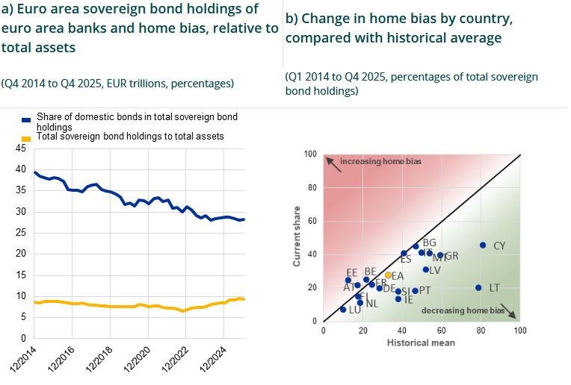
Source: ECB, Speech by SSM Chair (link)
Barriers to cross-border mergers and acquisitions
Diverging supervisory practices that could deter banking groups from undertaking cross-border consolidation could be linked to the process and timing to grant supervisory approvals for M&As, fit and proper approvals or approvals for the acquisition of qualifying holdings. Another example of such lack of coordination relates to additional supervisory requests from host authorities following an M&A and resulting in higher Pillar 2 and combined buffer requirements for the merged or acquired entities if the operation is perceived as bringing additional risks to the local market.
The absence of a uniform and transparent EU-wide supervisory assessment regime, including the lack of predictability in relation to expected capital requirements, can contribute to the low level of M&A deals in the EU. Banks may be concerned by the lack of clarity and transparency of the criteria to set Pillar 2 requirements to the entity resulting from the merger.
Such prolonged approval processes may add delays and costs, discouraging potential deals on cross-border transactions.
Moreover, the use of macroprudential policy tools at the national level increases the complexity of cross-border banks’ operations. The presence of banks from other Member States may reduce the effectiveness of the policy intervention and requires reciprocity of policy actions by home authorities, which multiplies the number of policy measures in place. Reciprocity is particularly cumbersome in operational terms if the measures are overly detailed and require additional granular data collections. Certain buffers, such as G/O-SII buffer and some SyRBs apply to all exposures of the institution and by construction cannot be reciprocated, which means that any differences in their calibration between Member States may affect the competitive position of the bank in all markets where the bank operates.
In general, industry representatives tend to consider that cross-border M&As are less attractive than domestic deals due to regulatory, supervisory, operational and political frictions that reduce expected synergies.
Non-prudential barriers
In the past decade, the low level of profitability of the EU banks has hampered cross-border banking in the EU. It discouraged banks from acquiring entities perceived as unproductive in another Member State, and low productivity at home narrowed the number of banks that were fit to undertake cross-border ventures. This effect pushed banks in the EU to develop their cross-border activities through ancillary services, such as leasing or insurance. While the situation has improved in recent years, a number of the biggest potential deals have stumbled upon the opposition of national governments, showing that national politics can also be a barrier to the single market.
Divergent legal systems (in particular company, insolvency, tax, employment or labour laws, collateral enforcement as well as judicial systems) and traditional factors such as differences in language, culture, and domestic product preferences fragment banking markets in the same way that they fragment other industries. Differences in taxation, including personal taxation for global employees or specific bank levies, consumer protection (e.g. affordability checks, repayment account structures, bank contract terms, servicing/complaints handling, marketing and advertisement), anti-money-laundering provisions (e.g. different remote client onboarding, lack of cross-border recognition of KYC checks, divergences in thresholds for suspicious activity reports) or data protection (divergent GDPR interpretation) at Member State-level result in bank-specific entry and adjustment costs that discourage cross-border banking.
Diverging product offering regulations may be another barrier to operate cross border. Examples include widespread advertising specifications for consumer loans, no harmonised data set for credit bureaus or diverging minimum interest rates for different products (regulated savings accounts, mortgage loans). Equally, consumer preferences may also be biased towards more familiar “national” products and brands.
While the possibility of acquiring ailing banks typically presents a good opportunity for banks to expand into foreign markets, uncertainties around asset quality, collateral enforcement, recovery rates (dependant on the judicial system) and high levels of NPLs seem to have discouraged banks from doing so in the last years. However, the steadily declining NPL ratios in the EU banking sector help attenuate this barrier.
The decline in cross-border banking during the GFC was, among other things, the consequence of public support schemes that often required banks to restructure their activities. Activities to support the domestic banking market could count on political backing, but there was much less appetite for banks to maintain activities in foreign markets. Such developments were also the result of the restructuring commitments undertaken by Member States for the approval of State aid operations, as it was perceived to be more difficult to communicate to taxpayers why public money should be used to prop up foreign operations. The fact that local policymakers might value the preservation of national banks above further banking integration seems also to be a factor that deters banks from entering a foreign market and indicates a high level of political interference in banking operations in some jurisdictions. Several respondents to the public consultation noted the existence of, sometimes excessive, government interventions in banks’ financial decisions. Public pressure has been observed in relation to extraordinary taxes and sector-wide levies, administrative restrictions on prices and fees, intervention in distribution policies and constraints on structural decisions (branch closure, workforce adjustment, territorial presence). Some respondents also noted that recent times were characterised by a growing trend towards a highly politicised environment in which the banking sector is being used as a tool in broader conflicts.
Stakeholders also indicate that non-prudential barriers are particularly prominent in discussions on digitalisation and retail expansion. Succeeding in one Member State does not automatically translate into success in another because of differences in national legal, tax, accounting and supervisory environments. Barriers are perceived particularly acute in smaller markets, where the costs of entry and adaptation may outweigh business opportunities.

    - Cross-border allocation of funds: efficiency and resilience
The current barriers to a free flow of resources within cross-border groups is a material example of fragmentation, contributing to the absence of a European dimension in the banking sector and the economic inefficiencies it generates. While this is largely a feature of the regulatory framework and the debate on completing the Banking Union, it may also be explained by a lack of initiatives from the banking sector itself to use the tools at its disposal to operate in other markets (e.g. restructuring of business lines and branchification, direct cross border provision of services), either by choice or because of supervisory or political pressure.
In this context, banks’ ability to operate cross border without barriers to allocate liquidity and capital is essential to improve the efficiency of banking groups and their financing of the economy. Moving towards an unhampered management of resources inside cross-border groups supports market integration and comes with important benefits such as freeing up resources that can be allocated more efficiently and agility in dealing with stress located in specific parts of the groups. It may also generate substantial second order effects to the benefit of all Member States, including: a diversification of risks across markets, scale effects that generate efficiency gains and support bank competitiveness, increased competition locally that can improve the offering of adequate financial services to citizens and businesses, reduced procyclicality in local markets thanks to the presence of foreign operators that may react differently to local shocks, etc.
Improving market integration in the banking sector should not be opposed to preserving financial stability or the presence of more local players. More efficient, more resilient banking groups, able to withstand shocks and be sufficiently competitive to support the financing of EU priorities can contribute to strengthen financial stability as long as adequate safeguards are in place, in particular a solid institutional and governance structure in the Banking Union. These safeguards should ensure that irrespective of what happens to the banking group and subsidiaries when they fail, the costs will not be borne locally.
Moreover, improving market integration in the banking sector should not mean a mechanistic reduction of the level of credit to the local economy, as demand for credit, and the sources of profits and competition it implies, will remain unaffected by the way bank liquidity is managed. In addition, experience shows that the presence of local requirements in each subsidiary is not a protection against commercial decisions to lower the level of credit in host Member States during a downturn.
Issues identified:
- Prudential regulation applies to all levels of consolidation. Liquidity requirements can be waived fully or partially on a cross-border basis, while capital requirements at solo level cannot be waived on a cross-border basis. However, in practice supervisors have not granted liquidity waivers on a cross-border basis in a substantive way.
- Other requirements constrain or limit the free intra-group transfer of resources. Including national large exposure limits as well as capital requirements on intragroup exposures.

    - Safety nets and resolution strategies
It is complex to find the right equilibrium that would allow for favourable conditions driving a more integrated banking market, for example through a more central management of liquidity and capital at group level, while at the same time providing assurances and safeguards protecting the financial stability in Member States where group entities are located.
A key concern expressed by some Member States is the risk that, absent sufficiently robust pre-positioned capital and liquidity, local subsidiaries of a foreign banking group would be cut off from the rest of the group in times of stress, forcing authorities to deal with the subsidiary in a disorderly manner. The arguments against more market integration in good times always come down to the risks at national level in bad (crisis) times, and are also related to a lack of trust among authorities. More specifically, most banking groups in the EU are subject to a single-point-of-entry resolution strategy, meaning that crisis management tools are supposed to be applied at the level of the parent while subsidiaries, especially when they provide critical functions for the economy, are left untouched. Breaking this ‘presumptive path’ is a source of concern for authorities who seek to mitigate any risk of being left to deal with local subsidiaries on their own. In addition, vulnerable subsidiaries insufficiently supported by the group – or healthy subsidiaries not considered as the group’s priority – may not be able to provide financing to the real economy in their Member States, which may adversely affect economic performance in these countries.
Integration of the deposit insurance framework in the Banking Union
Under the current crisis management framework, Significant Institutions (SIs) and cross-border less significant institutions (LSI) representing approximately 75% of covered deposits in the Banking Union fall under the direct responsibility of the SRB. Most of these banks are planned for resolution and comply with the requirements to have sufficient loss absorbing capacity (MREL). More than 95% of the covered deposits of those banks will be protected through other means than a depositor pay-out such as by the application of resolution tools, which will provide for uninterrupted access of depositors to their covered deposits. In the consultation, several stakeholders underline that banks under the direct SRB remit are already subject to sound resolution planning and strong MREL buffers and are unlikely to rely on DGS support in case of resolution.
The remaining 25% of covered deposits not held by banks under the SRB-remit are financing mainly national and local economies and governments. Crisis management tools used for these banks differ among Member States and specific subsectors of the national banking sectors. Most LSIs in the Banking Union are members of Institutional Protection Schemes that are recognised as DGS, which together hold 70% of all covered deposits in all LSIs in the Banking Union, and problems in individual members are expected to be addressed via the use of IPS measures.
Issues identified:
- While not the default scenario, pay-outs remain a possibility for banks under SRB-remit. Under the current CMDI framework, the SRB can decide both in planning and – due to a change of circumstances – at the moment a bank is failing or likely to fail, that a bank has a negative public interest and therefore should be liquidated. A single point of entry resolution strategy for a group can also break at the point of failure and some or all of the individual entities within a group would end up in liquidation. In these cases, the financial consequences of a negative public interest assessment or a failure of the resolution strategy – implying a depositor pay-out through the DGS – will be for the national banking sector to support, even though national authorities, while involved, are not in control of the bank’s supervision or resolution planning. Inasmuch as covered deposits under SRB remit are deposits in group subsidiaries located in Member States other than the Member State of the parent institution, this risk provides an additional incentive to ringfence bank capital and liquidity at entity level, limiting the benefits of liquidity and capital pooling at group level and failing to catalyse the potential benefits of the internal market.
- Without prejudice to internal support measures for IPS members, in case of failure, today most LSIs will be liquidated and covered deposits will be protected by way of DGS payout, preventive or alternative measures. Given the strong capital buffers in the system and the DGS super-preference, DGSs would rarely suffer material losses but they might face substantial liquidity shortfalls, as demonstrated in the ECB occasional paper and highlighted by many stakeholders in the responses to the consultation.
- Other LSIs are planned for resolution by national resolution authorities. Where the resolution of an LSI requires the use of the SRF, all requirements for access to the SRF should be fulfilled and the resolution scheme should be adopted by the SRB, despite the fact that the SRB has not been in the driver’s seat for the resolution planning and setting the MREL targets for the LSI. This results in subjecting LSIs that are considered ‘too big to be liquidated’ to the same complex MREL rules and conditions for access to the SRF as SIs. This is one of the reasons for the reluctance of some NRAs to expand the scope of resolution to LSIs. This results in pushing authorities to choose national winding-up procedures and payout of covered deposits even when resolution would be more efficient and would provide better and less costly protection of deposits, even though the recent CMDI reform provides additional tools to use DGS to cover possible funding gaps to access resolution funds. The consultation also indicates that some stakeholders consider access requirements to the resolution fund too rigid for smaller banks and not sufficiently reflecting differences in size and business model, while supporting the underlying principle that shareholders and creditors should bear losses before financial safety nets are used.
- Overall, a system in which there is a risk of misalignment between control and financial liability in case of failure and banks contribute to two different funds – one for protection of covered deposits and one for resolution – while it is clear that there is a preferred route to manage a bank’s failure with the possible use of only one of the funds – leads to overly complex arrangements and inefficiencies. This situation combined with the lack of any solidarity mechanism among financial safety nets results in the necessity to maintain higher total amount of resources in the safety nets, and ultimately, in increased financial burden on banks.
Predictability in the crisis management framework
To ensure an orderly management of failing banks, resolution authorities are required to prepare and draft resolution plans which detail a bank’s characteristics, determine whether it carries critical functions to the economy and identify which functions should be continued in case the bank fails. Based on this assessment, resolution authorities determine in advance whether a bank should be designated for liquidation and wound up under normal insolvency proceedings or whether the bank would need to be supported in resolution and under which preferred resolution strategy. However, on the day of a bank failure, resolution authorities may decide that it is no longer in the public interest to resolve the bank or to change the resolution strategy.
Issues identified:
- While it is essential that resolution authorities retain a certain degree of flexibility on the day of a crisis to adapt to conditions which could not have been foreseen in the resolution plan, it is also important to recognise that last-minute changes to how bank failures are managed can create significant concerns for authorities regarding the potential fallout for the local economy beyond the protection of depositors. This is in particular relevant for Single Point of Entry (SPE) group resolution plans where local authorities may be called on managing the liquidation of a subsidiary without adequate planning, as this was not part of the initial resolution plan.

    - Liquidity in resolution
The success of a resolution depends on its ability to restore market confidence and allow the resolved bank to finance itself on the market as soon as possible. Trust can be achieved through robust resolution planning, timely failing-or-likely-to-fail declaration, decisive resolution actions, including the bail-in of shareholders and creditors, the return of bank to viability and effective communication that provides confidence to market participants (e.g. clear and credible messaging about the resolution strategy).
However, the exceptional nature and the potential impacts of resolution actions may raise concerns from various stakeholders, affected or not by the resolution, who may decide to stop transacting with the newly resolved bank despite the successful intervention of public authorities. As stated in the FSB 2024 resolution report, ‘[i]n the period following the commencement of a resolution process, even a recapitalised bank could experience heightened liquidity needs generated by market volatility’. In this respect, several jurisdictions have introduced facilities to deal with such challenges.
Issues identified:
- While the various regulatory steps taken since 2008 have led to a healthier banking system overall, the tail risk of banks that are deemed too-big-to-fail and whose disorderly failure can affect, directly or indirectly, the entire EU economy in similar ways as during the great financial crisis still remains due to the lack of an adequate framework for liquidity in resolution. This justifies dealing with such tail risks beforehand in a predictable manner. Potential liquidity needs of a global-systemically important bank or several medium-size banks can be particularly large, even though only needed for a short period of time before the resolved bank secures again full access to private funding after resolution. These temporary liquidity needs may largely exceed resources that could be available in the bank itself immediately after the ‘resolution weekend’ – e.g. due to the lack of assets to be pledged as collateral – or in safety nets such as the SRF and, if implemented, the ESM common backstop to the SRF. These temporary liquidity needs may only partly be mitigated by stricter measures aimed at increasing banks’ resolvability or early failing-or-likely-to-fail declarations. To protect financial stability in the EU, the introduction of effective public sector backstop mechanisms for the provision of liquidity in resolution is necessary, as recognised by the FSB.
In the Banking Union, and in absence of a European mechanism, the temporary provision of emergency liquidity assistance (ELA), provided by and at the discretion of the respective euro area national central bank (NCB) to a solvent bank, has historically been used to provide liquidity. This has usually required the use of national guarantees to ensure that the ELA is provided against adequate collateral. This approach as, however, drawbacks.
- All losses are national. Whether directly as of guarantees or indirectly as of recapitalising the respective NCB(s), any losses incurred by the provision of liquidity due to a bank’s default are attributed to the individual Member State. Under such a system, there is no possibility to ensure that public support is fully repaid by contributions from all BU banks.
- Such transmission of bank risks to the sovereign with no mitigation or repayments has potentially negative implications for the sovereign financing, reinforcing the bank-sovereign nexus that BU reforms had intended to help weaken.
- The national specific approach goes against the design of the BU and is incompatible with the institutional architecture of the BU, where the responsibility for the supervision and the resolution of significant institutions has been allocated to the European level.
Responses to the targeted consultation also show that various market participants consider that the discretionary nature of ELA creates uncertainty on the success of the resolution, requiring them to guess authorities’ reactions and increasing chances of a self-fulfilling liquidity crisis.
The lack of an adequate European mechanism results in persistent gaps in the crisis management framework that undermine credibility and trust in the ability of the Banking Union to deal with the failure of large banks in an orderly way. This uncertainty also creates risks for national budgets, the EU economy and the financing of the EU priorities.
The vast majority of respondents to the consultation would support a more transparent and predictable European mechanism ensuring the provision of liquidity in resolution as a key tool to strengthen the effectiveness and credibility of the European crisis management framework.
Addressing this issue would greatly contribute to strengthening financial stability in the Banking Union, and more largely in the EU. In addition, by providing adequate means to stabilise the financial situation of a parent entity within a group, a robust mechanism for liquidity in resolution can also help mitigate concerns about the impact of measures supporting a more efficient cross-border allocation of funds within banking groups as the probability that a parent could not support its own subsidiary due to lack of available liquidity would be greatly minimised. Progress on the issue of liquidity in resolution is therefore closely linked to the ability to improve market integration and simplify the regulatory framework.

  - Implementation of international standards in the EU – Main issues
    - Output floor
The output floor is one of the elements of Basel III, agreed in December 2017. It is a measure that sets a lower limit (‘floor’) on the capital requirements that banks calculate when using their internal models (‘output). In practice, the output floor acts as a backstop for the internal model approaches on the basis of the standardised approaches of the Basel standards.
The output floor impacts specifically the computation of the own funds’ requirements for credit risk and for market risk, where institutions are still allowed to use internal model approaches. One of the criticisms against the output floor is that it compares the risk weights determined by internal models, developed by banks on the basis of their real-life observations (e.g. on default data), using modelling techniques that are authorised and supervised by competent authorities, to the risk weights of the standardised approaches calibrated by the BCBS using US data only, whereas EU and US banking intermediation activities have structural differences in products, markets and clients. Another key criticism is related to the fact that its calibration at 72.5% may make the output floor binding in a too high number of cases, with detrimental effects on risk sensitivity. In the EU, internal models of banks have undergone a decade of supervisory scrutiny and are supervised on an ongoing basis. Examples of such supervisory activity over the years are the TRIM project, supervisory benchmarking, ongoing model monitoring activities and an established framework governing model changes.
The output floor requirement was introduced into European legislation through the CRR3 in January 2025. The transitional arrangements for the output floor are set in Article 465(1) CRR. The output floor is expected to be fully phased in by 1 January 2030 and it is currently at the level of 55%.
1 January 2025 to 31 December 2025 | 50%
1 January 2026 to 31 December 2026 | 55%
1 January 2027 to 31 December 2027 | 60%
1 January 2028 to 31 December 2028 | 65%
1 January 2029 to 31 December 2029 | 70%
1 January 2030 | 72.5%
Issues identified:
Calibration of the output floor
- Heterogeneous application across major jurisdictions. The BCBS framework is designed to be implemented uniformly. However, the international practice differs widely among major jurisdictions. The newest US proposal (March 2026) includes more than 20 downward deviations and reduces gold plating. The UK Prudential Regulation Authority published its final Basel 3.1 policy statement in January 2026, delaying the implementation by one year, to 1 January 2027. Thus, like for other international agreements, the faithful transposition of Basel requirements is subject to specific features of the jurisdictions: they may have structural differences in banking markets and the role of bank lending for the economy, and they may thus be applied more progressively over time.
Jurisdiction | Current floor level | Roadmap to 72.5%
EU | 55% | By 1 January 2030
Australia | 72.5% | n/a
Japan | 60% | By 31 March 2029
Canada | 67.5% | Frozen
UK | Not started | To start by Jan 2027, fully-fledged by Jan 2030
US | Not implemented

- Relevance of risk-based requirements. The last EBA’s Basel III monitoring report (2024) shows that when fully implemented, nearly 80% of EU banks will be constrained by the output floor or leverage ratio, meaning that risk-based requirements will become secondary for the majority of EU banks. More recent research by the SSM suggests that approximately 20 significant institutions under their supervision may be bound by the output floor in the steady state.
- EU structural business models. EU banks rely predominantly on on-balance sheet lending (mortgages, corporate loans held to maturity), whereas US banks make extensive use of fee-based models and transfer mortgages to government-sponsored enterprises, moving the exposures that most heavily impact the floor off-balance sheet. This is not a calibration issue but a structural feature of European financial intermediation that makes the same floor more binding in the EU than in the US. At the same time, the output floor has a much stronger impact on the European economy because it is much more dependent on bank-based financing than the US economy that relies more heavily on well-developed and large capital markets.
Level of application
- Divergent application in the EU. The BCBS framework calibrated the output floor at the consolidated group level. The rationale was clear: the floor is a portfolio-level backstop. A group with a diversified portfolio across subsidiaries in multiple countries may have low aggregate internal model risk while individual subsidiaries show higher or lower IRB-to-SA ratios, depending on their specific portfolio mix. Applying the floor entity-by-entity produces a mechanically different and more punitive outcome than the Basel Committee intended or modelled in its impact assessments.
Following a proposal by the Commission in 2021 to apply the output floor only at consolidated level, the interinstitutional negotiations led to a different approach, whereby the output floor would apply at both the consolidated level and at the individual/sub-consolidated level, for each legal entity within the group (Article 94(4) CRR3). The logic was:
- Host country supervisory control: retaining the ability to ensure local entities held sufficient capital, particularly given the absence of a completed Banking Union (in particular the absence of common deposit insurance and unresolved issues to enhance cross-border crisis management).
- Capital drain risk: without solo-level requirements, parent groups could upstream capital from subsidiaries in stressed periods, leaving local depositors and taxpayers exposed.
The application of the output floor at individual level is a deliberate EU gold-plating over the Basel III standard.
Risk areas of application
- Scope of the output floor (credit risk only or full balance sheet). The application of the output floor as a single stack considering all risk areas creates disincentives for banks to develop market risk internal models, which instead have positive effects on banks’ risk management practices.

    - Credit risk
Credit risk is the dominant risk category for EU banks, amounting to approximately 82% of total risk-weighted exposure amounts (RWEAs), that reflects the central role of the banking sector in financing households and businesses. Notably, the corporate sector, especially small and medium-sized enterprises (SMEs), startups and scale ups, rely heavily on bank lending as main source of financing. Consequently, competent authorities focus strongly on prudential requirements and financial stability objectives.
The Banking Package adopted entered into application in 2025 (CRR3) led to amend the EU credit risk prudential framework for banks applying both the standardised approach (SA) and the internal ratings-based approach (IRB approach), and added a very relevant new element, markedly the Basel III driven output floor, agreed internationally in December 2017, as an additional prudential backstop. The objective of the output floor is to limit the variability in the estimation of RWEAs under the IRB approach and relates it to the RWEAs calculated applying the SA for credit risk.
The objective of the prudential framework is to make sure banks adequately cover their credit risks by setting aside capital for unexpected losses. But it is equally important that the framework does not unduly restrict lending capacities by requiring levels of capital beyond the statistically defined level of economic stress. Effective supervisory review of lending practices and banks’ corporate governance should contribute to limit unexpected losses on EU banks’ credit portfolios.
Getting the regulatory and supervisory balance right in the EU is instrumental for the safety and soundness of the banking sector and for maintaining sufficient funding for strategic economic sectors and the EU’s strategic priorities. It would also reduce the potential for moving funding sources to less-regulated non-bank lenders (e.g., private credit markets), a move which could even worsen the safety and soundness within the financial sector.
Issues identified:
- Market transparency is an asset that can help corporates to tap capital markets. At the same time, there is a need to make sure that the prudential treatment of banking exposures toward unrated corporates with good credit histories remains balanced, proportionate, and consistent over time. The EU framework presents a high structural insulation against borrowers’ default, which is reflected only to a limited extent in the standards agreed at international level at Basel. This is the case also considering segments of low-risk residential mortgages based on a wide-array of structural safeguards with a long and proven track record.
- Modelling outcomes under the IRB approach and the relative distance between the IRB approach and the SA resulting in major adjustments when applying the output floor, should be further analysed. This is especially relevant for exposures showing low default rates and for which strong legal and structural setups protect financial institutions. In these lines of business EU banks developed good expertise and experience in controlling the inherent riskiness of their exposures, without an adequate recognition in the prudential framework e.g. specialised lending (e.g. aircraft, shipping, rail, critical and green transition infrastructures), leasing, trade finance, etc.
- The current treatment of investments in software assets may determine disincentives to robust investments in IT capabilities, while the prudential framework should not hamper banks’ development of IT capacities both on grounds of competitiveness and regulatory compliance.

    - Market risk and FRTB application
Basel III introduced a revised standard for market risk, also known as the Fundamental Review of the Trading Book or FRTB, adopted by the BCBS in January 2016 and further reviewed in 2019. The EU implemented the FRTB in its legal framework in two phases, first as a reporting requirement, via CRR2 (amending Regulation (EU) 2019/876) and then as binding capital requirements via the 2024 Banking Package and CRR3 (amending Regulation (EU) 2024/1623). However, despite CRR3 and Basel III entered into application on 1 January 2025, the application of the FRTB in the EU was postponed twice via Commission delegated acts to 1 January 2027, in light of the US’ and UK’s delays in their own implementation of the Basel standards. On 4 June 2026, the Commission adopted a third delegated act on market risk, which is currently under scrutiny by European Parliament and Council. The delegated act introduces targeted amendments to the EU implementation of the FRTB.
Competition between internationally active banks is very intense in trading activities, due to the ease with which those activities can be conducted across jurisdictions, including between Member States and third countries or through branches. Misalignments in the implementation of internationally agreed standards for market risk, both in terms of timeline and content, can have repercussions on the level playing field for EU banks and bring significant consequences on the capacity of the EU banks to compete in those markets. EU banks would lose competitiveness / market share in trading activities to the advantage of their lighter-regulated international competitors, both in international markets (US, UK, Asia) and in the EU itself, where US banks hold a significant market share. Also, misalignment might cause some trading activities to migrate from EU markets to other lesser-regulated jurisdictions, actually going against SIU objectives.
Issues identified:
- Overall uncertainty over other jurisdictions’ implementation of the FRTB, both regarding timeline and content, and level playing field implications.
- More monitoring is needed, to feed reflections for the permanent solution regarding the FRTB implementation, together with the measures introduced in the Commission delegated acts and broader reflections on the EU approach to Basel
- Only few banks have request competent authorities’ approval to use internal models. This is an issue as internal models are more appropriate for banks with sophisticated activities, they aid developing risk management capabilities and avoid herd effects on specific instruments or activities (which may be discouraged by the risk weighting of the standardised approach).

  - Undue complexity of the framework – Main issues
Complexity is inherent to financial services regulation, in particular in the area of banking. Banks require strict regulation and intrusive supervision, because they are fundamental to the financing for the EU economy and inherently vulnerable to runs on their primary funding source, deposits, which may create financial instability. Banking also remains a highly complex endeavour, and the regulations reflect this complexity.

    - Institutional set-up
- Implementing international standards in the EU regulatory framework
The EU bank regulatory framework is based on a central assumption that, in a single market, adequate regulation should apply to all banks across the EU. This led to subject the entire EU banking system to policies deriving from international standards developed in the Basel Committee for Banking Supervision (BCBS) and the Financial Stability Board (FSB), while they were initially designed for systemic banks. This approach leads to further complexity given the need to adapt rules to cater for EU specificities, while ensuring broad compliance with international standards. These differences are based on political agreements among co-legislators and reconcile the abstraction of international standards with the reality of the EU banking sector and its environment (different banking landscape compared to other international jurisdictions, European and national safety nets, differences in national laws, need for proportionality). Still, they are a source of complexity and lack of comparability.

- Interinstitutional architecture and transversality
The EU is a complex multi-jurisdictional political structure with a democratic, transparent and accountable legislative decision-making process, but which often produces additional complexity through the political negotiation process.
This means that, on top of adopting internationally agreed standards, introducing numerous EU-specificities (e.g. exemptions, derogations) in the single rulebook to cater for national interest groups or specific business models is necessary to achieve a consensus among the EU co-legislators. In addition, compared to other jurisdictions, the EU banking regulation in the EU tends to be more rule- than principle based, to ensure a harmonised application and level playing field among Member States.
Complexity can also arise because of the design of the regulation, where simplicity is sacrificed to attain other objectives, notably risk sensitivity, robustness, cost efficiency, comparability. Complexity can also be the characteristic of the lack of transversality in the setting up of rules that does not consider the safeguards considered by other parts of a global framework.

- Multiplicity of sources of legislation
The multiplicity of sources of legislation and guidance also contributes to complexity. EU legislative acts (Directives, Regulations) and secondary acts (Delegated and Implementing Regulations) are numerous and often very prescriptive. With 3 main Directives and 3 main Regulations, EU legislative acts in the area of banking regulation have reached an unprecedented level of coverage and granularity, in Level 1. The complexity of the rules also leads to introduction of additional empowerments for a high number of Level 2 acts (more than 100 in the latest Banking Package alone), requiring important efforts to ensure that the framework can be developed on time and implemented as intended. In the financial services legislation at large, 430 empowerments have been added solely for the 2019-2024 legislature (and 115 deprioritised). The banking framework also interacts with other EU regulations, including ESG reporting or digital operational resilience (DORA) that amplify the impact of this accumulation of rules.
In addition, Level 3 guidance (Guidelines and reports, authorities’ guidance), which can be developed on the authorities’ own initiative to ensure harmonised implementation of the EU rules or to limit discretion and ensure a level playing field, is often used and perceived as binding to a similar extent as EU law. While guidance should contribute to the maturity of the prudential framework and ensure clarity, homogeneity and a level playing field in terms of implementation, their degree of detail and prescriptiveness can often be seen as counterproductive.
Recurrent issues include:
- The nature of such guidance is debated: while guidelines are not legally binding, the ‘comply or explain’ mechanism, combined with public disclosure of non-compliance, creates pressure on authorities to adhere to them. This, in turn, forces banks to follow the guidelines ad litteram, as Union law is silent on which would be the consequences for banks breaching guideline provisions (not following a guideline, for a bank, may increase the risk of non-compliance and of sanctions).
- Authorities who have declared compliance with a guideline can in any event supplement it with additional measures nationally. This reduces convergence instead of fostering it.
- In so far as the Banking Union is concerned, there are de facto two comply-or-explain mechanisms per Member State: one by the European authority (ECB and SRB) for banks in their remit, and a second one by the national authority for the rest of the banks, with possible inconsistencies between the two approaches.
The use of Directives, requiring transposition in national laws, is also a factor that increases complexity and risks of divergent designs and applications of national laws that can ultimately, in particular for Directives of minimum harmonisation, lead to gold-plating practices.
Moreover, the governance of the requirements, i.e. the way supervisory, resolution and macro-prudential authorities tend to apply them to banks in concrete cases, can further increase complexity through additional layers of internal guidance and interpretative notices.
Due to its legal nature, and the piece-meal approach to producing and adopting legislation, the EU regulatory framework also has many internal and external cross-references that impede readability and a comprehensive understanding of the set of rules. Combined with legislative instability (since 2015, CRR has been amended 21 times and BRRD has been amended 11 times—either directly or indirectly through amendments stemming from other legal acts), this EU regulatory framework is a source of risk, slowing down decision making due to the potential side effects and the cross-references of a framework trying to be consistent in all its dimensions. This dynamic evolution of rules creates a "moving target" for compliance. This forces banks to continuously adapt their systems and processes, diverting resources from core risk management to reactive compliance efforts.
The consultation reveals that there is a broad consensus among stakeholders that the primary sources of undue complexity lie in supervisory soft law, the proliferation of Level 2/3 measures, and national implementation differences. The interaction between multiple frameworks—prudential, macroprudential, resolution, and emerging areas such as digital resilience and ESG—is also recognised as a key challenge, though stakeholders differ in their assessments of whether this complexity is justified by its policy objectives. In more details:
- Supervisory guidance and soft law stand out as the most quoted source of complexity. Banks and business associations consistently highlight that Pillar 2 requirements, EBA Q&As, and ad-hoc supervisory expectations effectively create a "fourth layer" of regulation, operating alongside formal legislative instruments. National authorities acknowledge the necessity of supervisory flexibility but recognise that greater structuring and transparency could reduce uncertainty. On the other hand, same of that complexity is derived from banks’ own requests for further clarity (notably through Q&As).
- The proliferation of Level 2 and Level 3 measures is the second most frequently cited concern, with stakeholders across all groups arguing that regulatory technical standards (RTS), implementing technical standards (ITS), and EBA guidelines are perceived to be at times too detailed and lacking proportionality. Banks and business associations criticise the excessive granularity and frequent updates of these measures, which divert resources from core risk management activities without necessarily enhancing prudential outcomes. Some highlight that delays or inconsistencies in implementation force institutions to adopt overly conservative interpretations, further increasing compliance costs. National authorities, while recognising the necessity of technical specifications for harmonisation, suggest that a more disciplined approach—including the sunsetting of outdated measures and consolidation of overlapping requirements—could reduce complexity. NGOs and academia adopt a more critical stance, arguing that these instruments often amplify rather than clarify Level 1 provisions, leading to redundancies and distortions.
- National implementation differences are widely identified as the third major source of complexity, fragmenting the single rulebook and complicating cross-border operations. Banks and business associations emphasise that gold-plating and divergent transpositions of national options create an uneven playing field that increases compliance costs without clear benefits. Some banking associations further note that differences in macroprudential tools and insolvency regimes undermine the framework’s harmonising intent. While national authorities defend the need for some discretion to address jurisdiction-specific risks, they acknowledge that greater convergence in supervisory practices could reduce unnecessary complexity.
- Interactions with other EU and national legislation are also identified as a growing source of complexity, particularly as non-prudential requirements—such as those under DORA, ESG reporting, and accounting rules—increasingly overlap with banking regulation. Banks and business associations highlight that these obligations often duplicate or, in the case of accounting rules, conflict with prudential requirements, creating redundant compliance burdens. National authorities recognise the need for cross-sectoral legislation but suggest that better coordination between the Commission, EBA, and other EU agencies could help align different policy areas and streamline compliance.
- Finally, while banks and authorities focus on operational and procedural challenges, NGOs and academia highlight deeper structural issues in the EU banking framework. They argue that the current "repair-based paradigm"—where successive crises lead to new layers of regulation without addressing fundamental design flaws—has resulted in a fragmented and overly complex system.

- Multiplicity of actors
The multiplicity of actors in charge of implementing the framework can also contribute to complexity.
For prudential matters, national competent authorities (micro-prudential supervision), national resolution authorities, national macro-prudential authorities, national central banks and national designated authorities overseeing deposit guarantee schemes, sometimes under a same roof, coexist with the European Central Bank (ECB), the Single Resolution Board (SRB), the European Banking Authority (EBA), the European Systemic Risk Board (ESRB) or even the European Commission (competition policy, specific role in crisis management framework). Other actors complement this mapping on other areas that are relevant for banking activities.
Progress has been achieved through the establishment of the Banking Union with an integrated cooperation and decision-making in the Single Supervision Mechanism (SSM) and the Single Resolution Mechanism (SRM) , including coordination between the ECB and the SRB, the coordination between European Supervisory Agencies (EBA, EIOPA and ESMA) or, in the area of reporting, the recently set-up Joint Bank Reporting Committee (JBRC). When expanding beyond prudential matters, other actors also play a role such as financial intelligence units, data protection authorities, consumer protection authorities or deposit guarantee schemes. However, despite the existence of legal delineations granting different powers and tools to different authorities, the coexistence of a high number of authorities can be conducive to complexity and inefficiencies if their roles and responsibilities are not clear and if coordination for their respective tasks is not optimal.

- Implementation practices and supervisory culture
The consultation reveals that supervisory discretion is perceived as a factor leading to inconsistent outcomes. The broad discretion exercised by supervisors—particularly in Pillar 2 assessments, internal model approvals, and stress testing—is identified as a major source of complexity. Banks report that supervisory expectations frequently exceed formal regulatory requirements, creating additional burdens without clear risk justification, exceeding what is necessary to ensure prudential stability and do not adequately reflect the risk areas and specificities of different business models. The lack of transparency in how discretion is applied results in divergent outcomes across jurisdictions, reducing planning certainty and increasing compliance costs, especially for cross-border banking groups.

    - Micro-prudential requirements
- Pillar 2
Pillar 2 is a core component of the capital framework for the EU banking sector, complementing the standardised Pillar 1 requirements with supervisory tools tailored to individual banks by addressing bank-specific risks and supporting institution’s capacity to withstand potential stress scenarios. In its practical application, institutions are subject to the Supervisory Review and Evaluation Process (SREP) in which supervisors form a view of banks individual risk profiles and engage in a dialogue with the institution. Following the SREP, institutions can be subject to supervisory capital add-ons covered by the Pillar 2 requirement (P2R), a legally non-binding Pillar 2 guidance (P2G) specifying the capital levels banks should maintain beyond mandatory requirements, and qualitative measures. In the P2R supervisors assess risks that are not, or not sufficiently, captured under Pillar 1. The P2G is a forward-looking measure based on supervisory stress test outcomes.
The EU Pillar 2 approach implements the “Supervisory Review Process” laid out in the Basel standards a principles-based approach granting flexibility to jurisdictions to implement measures addressing additional risks not covered by the framework. The Basel framework does not prescribe a specific capital add-on, its order and interaction within the capital stack, nor does it specify the type or quality of capital required to satisfy Pillar 2 requirements and disclosure obligations. The prescriptive and expansive nature of the EU Pillar 2 implementation of the Basel framework has given rise to concerns regarding consistency, transparency and global competitiveness, diverging from the implementation by other jurisdictions. Stakeholders have raised concerns about the current design and application of Pillar 2 requirements and guidance, notably possible overlaps with other requirements which could lead to double counting. Concern has also been raised regarding the limited transparency of the methodologies used to set Pillar 2 measures with a demand for a clearer breakdown of decisions, increased clarity and incentives relating to remediation and a better reflection of underlying risks. At the same time, the robust supervisory approach is a key strength of the EU framework. It allows supervisors to identify, measure and manage bank-specific risks, incentivises banks to improve their risk management and strengthens the resilience of the EU banking sector by ensuring a sound capitalisation of individual banks.
The following descriptive figures shed light on how Pillar 2 has been applied in practise.
Figure 26 – Developments in overall capital requirements and Pillar 2 guidance – the total capital stack
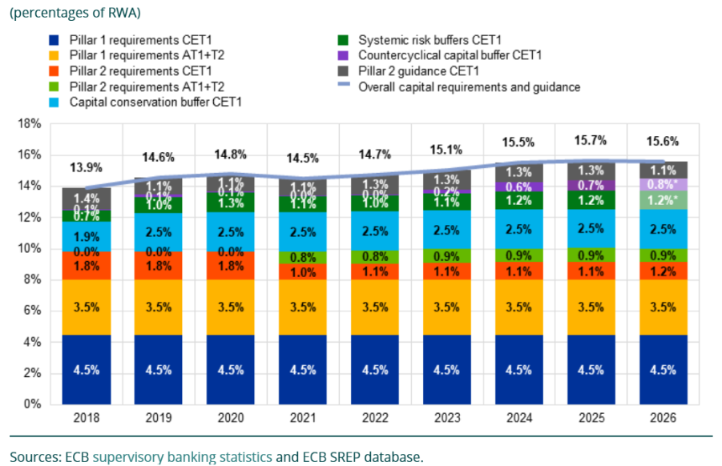
Source: ECB aggregated results of the 2025 SREP
Figure 26 shows the evolution of the EU going-concern capital stack between 2018 and 2026 for significant institutions supervised by the SSM, distinguishing between the different layers of the total capital stack. It illustrates that Pillar 2 capital layers have remained broadly stable in recent years. The chart also shows that P2R and P2G remain separate layers of capital within the capital stack, with different legal and supervisory functions. The P2R can be fulfilled with different capital instruments, while the P2G is expressed as CET1. The graph provides context regarding the discussion on simplification of the framework, as well as the development of the level of requirements over time.
Figure 27 – Percentage contribution to P2R by risk (overall P2R = 100%)
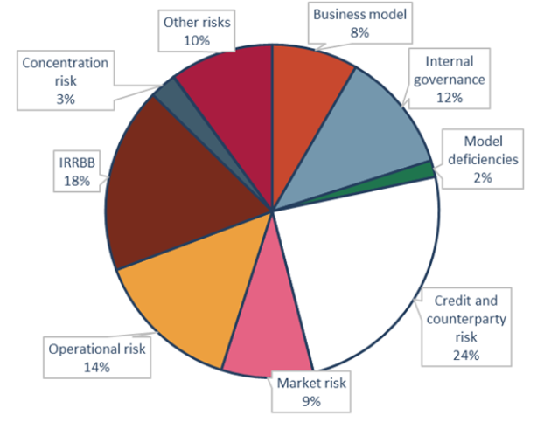
Source: EBA Convergence Report – 288 banks
The pie chart presents the contribution of different risk categories to total P2R. Credit and counterparty risk represents the largest share, followed by IRRBB, operational risk, internal governance, market risk, business model risk, concentration risk, model deficiencies and other risks. The figure shows the distribution of P2R components that are capturing risks insufficiently addressed in Pillar 1 (credit, market and operational risk), and risks not addressed in Pillar 1 (including IRRBB, governance, business model and concentration risk).
Figure 28 – Distribution of total capital Pillar 2 requirements (percentages of RWA)
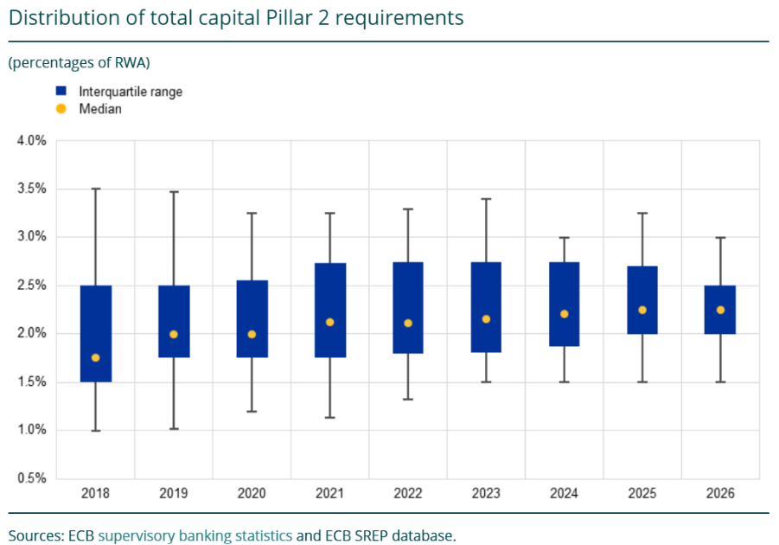
Source: ECB aggregated results of the 2025 SREP
The graph shows the distribution of total capital P2Rs over time, including the median, the interquartile range and the 5th and 95th percentiles. It indicates that the median P2R has been broadly stable in recent years, while the interquartile range fluctuates, and has narrowed in the most recent year.
In recent years, the SREP and Pillar 2 requirements have been amended through regulatory changes⁹³, and supervisory methodologies are regularly updated. The ECB Banking Supervision has recently implemented a new P2R methodology and proposed a reform agenda intended to increase the efficiency, effectiveness and risk-based focus of prudential supervision. These reforms are an important step in ensuring an adequate supervisory review framework.
Taking into account the international level playing field and the need to simplify the prudential framework, further steps could be considered, to ensure that supervisory requirements remain risk-based, proportionate and sufficiently predictable, while avoiding unnecessary complexity or overlaps within the capital framework.
Issues identified:
- Competitiveness and level playing field concerns: EU banks argue that the implementation of Pillar 2 in the EU is more conservative and complex than in certain other major jurisdictions, potentially resulting in higher capital requirements and placing them at a competitive disadvantage. Other assessments point in a different direction and provide evidence that the capital requirements are not a competitive disadvantage.
- Potential overlaps and double counting: Concerns persist regarding possible overlaps between Pillar 1, Pillar 2 and macroprudential buffers. These concerns should be assessed carefully, distinguishing between actual double counting and the use of different instruments for different prudential purposes.
- P2G perceived as quasi-binding: Although P2G is formally non-binding, many EU banks perceive it as a de facto requirement due to supervisory expectations and market sensitivities. This may reduce institutions’ flexibility in capital management and contribute to the build-up of management buffers above regulatory minima. This issue is also relevant for the broader discussion on the clarity of communication around the consequences of temporarily operating below P2G.
- Limited transparency and predictability: Stakeholders frequently report insufficient transparency regarding the methodologies underpinning the calibration of P2R and P2G and the supervisory communication of the final SREP decision, including how supervisory findings translate into specific capital add-ons and the intensity of supervision.
- Limited risk sensitivity of outcomes: The relatively stable and clustered nature of Pillar 2 over time, and between institutions, in the methodology of supervisory authorities, has led to perceptions that the framework does not sufficiently differentiate between institutions’ risk profiles. At the same time, stability may also reflect supervisory choices, methodological safeguards, the need for predictability and similarities in risk profiles across institutions
- Pillar 2 leverage ratio elements: the number of elements in the EU leverage ratio stack exceeds that of the Basel standards.

- NPL framework
The prudential treatment of defaulted exposures presents one key trade-off.
On the one hand, a lenient treatment can potentially conceal the risks and losses building in the balance sheets of banks, thereby artificially inflating their financial position. In turn, this would not only mislead creditors (including depositors) and investors about the stability and profitability of banks; but it could also mislead their supervisors about the actual compliance with prudential requirements, thereby postponing corrective actions to a stage which is too late to recover the situation. At the macro-level, when the losses finally crystallise, banks might be unexpectedly declared as failing – potentially at the same time – with unforeseen consequences for financial stability.
On the other hand, a too stringent prudential treatment reinforces the pro-cyclicality of prudential requirements in a downturn. This is due to the impact of the classification of an exposure as defaulted for banks, obligors, and the economy at large. Classifying an exposure as defaulted forces banks to deduct the losses from their own funds and to apply higher risk weights to the remaining part. For obligors, a default classification adversely affects their credit risk score and triggers the default classification of potentially all their exposures to the bank. If wrongly calibrated, the combined effect of these prudential requirements could lead to prolonging downturns as banks would be forced to cut their credit supply, thereby limiting the access to credit by businesses and citizens when the economy most needs it.
Therefore, the key objective of the NPL framework is to ensure the stability of both individual banks and the banking system as a whole while preserving their ability to finance the economy in stressed scenarios.
The EU has introduced a set of measures – both legislative and non-legislative – to tackle the exceptional high level of NPLs built up in the aftermath of the financial crisis and successive recessions, which was negatively affecting their soundness and thus their ability to provide credit to the economy. Such measures have decisively contributed to the current NPL ratio, which is at low levels.
From a micro-prudential perspective, the most significant measures have been the introduction of the NPL backstop and the definition of default set by article 178 CRR as further specified by the EBA Guidelines on the Definition of Default. The former is a structural, pillar 1 measure which forces banks to comply with minimum provisioning within certain deadlines if they incur into non-performing exposures (NPEs), whereas the latter clarifies when an exposure should be considered as defaulted for prudential purposes. Although the definitions of NPE and defaulted exposure are slightly different (the former includes the latter) due to historical reasons, they overlap to such an extent that the relative difference between NPE and defaulted amounts is negligible in aggregate terms.
Issues identified:
- While it has proved instrumental to reduce the stock of NPLs in the EU from dangerously high levels to historical lows, questions on the forward-looking nature of the NPLs framework across cycles are legitimate. In particular, it is worth considering whether the current calibration of the NPL backstop and the definition of default excessively reduce the ability of banks to proactively engage with clients at an early stage even if there are grounded prospects of recovery, including in the presence of legislative moratoria.

    - Crisis management
- Loss-absorption requirements (MREL and TLAC)
EU banks are required to hold a minimum amount of own funds and eligible liabilities (MREL) set by resolution authorities, to ensure that a failing bank can be resolved without resorting to taxpayers’ money. This requirement derives from the Total Loss-Absorbing Capacity (TLAC) requirement defined by the FSB and applicable to G-SIBs. The introduction of MREL requirements has significantly increased the resilience of EU banks ensuring that they have enough resources to absorb losses and to reopen after bail-in post resolution. However, the current design of the MREL requirement has proved to be unduly complex, duplicative and opaque and should be addressed in a revised framework.
Issues identified:
- Duplication of the capital stacks – MREL and TLAC do not use the same eligibility criteria for the instruments that can be used to comply, nor do they rely on the same calculation methods. This has resulted in a duplication of the capital stack required for globally systemic banks which need to meet both requirements separately.
- Complex and discretionary rules – the current calibration of rules tries to anticipate per bank the amounts necessary for the absorption of losses and recapitalisation of banks after the resolution. The number of adjustments per bank (linked to their balance sheet, resolution strategy, etc.) have made the framework overly bank-specific which hinder its predictability and consistency and weaken the level playing field across banks.

- Buybacks and liability management
The MREL framework also comes with ancillary provisions, inspired from the own funds requirements, that are sometimes unduly complex or do not deliver as expected which should be addressed as well. For example, prior to the early redemption of eligible liabilities instruments used towards compliance with MREL, banks are required to obtain the authorisation of the resolution authority. This procedural burden has direct implications on the ability of banks to refinance their liabilities, in particular when market conditions would allow to benefit from more competitive market rates.
The prior permission regime has been subject to a few simplification initiatives, within the limits of what CRR and the Delegated Regulation on own funds and eligible liabilities allow. In particular, the Single Resolution Board published on December 2025 a new approach to accelerate the process and ease the implementation of these provisions. However, these changes do not provide meaningful relief for banks operating in volatile market environments and still represent an important source of administrative burden for resolution authorities. A vast majority of respondents to the targeted consultation also recalled the importance of a speedy and unhampered process for the redemption of eligible liabilities when authorities consider there is no impact on financial stability.
Issues identified:
- While originally designed to safeguard the soundness and integrity of institutions’ loss-absorbing capacity, the prior permission regime has introduced unnecessary complexity and administrative burden on banks and resolution authorities, for little added-value in terms of resilience and financial stability.

- Resolution planning activities
Under the EU bank resolution framework, the SRB and National Resolution Authorities (NRAs) are required to develop and draft resolution plans for the banks under their remit, with the aim of preparing to manage their orderly failure. Resolution plans are comprehensive documents, which describe the characteristics of a bank and outline the preferred resolution strategy and resolution tools to apply. The framework also specifies the frequency and the key steps of the resolution planning cycles, as well as the procedures to be followed for their preparation and adoption in cooperation with other relevant authorities.
Some respondents to the targeted consultation emphasised the importance of further harmonising data requirements to reduce duplication, inconsistencies, and operational burden, which can be achieved by enhancing the alignment between the resolution framework and supervisory reporting. Others advocated for enhanced cross-border cooperation through the expansion of joint testing, information-sharing mechanisms, and international coordinated drills, aiming to ensure the efficient and predictable operation of cross-jurisdictional crisis management.
Issues identified:
- Despite the important steps to shorten and standardise resolution plans which have already been conducted by the SRB and by EBA with the revised RTS on resolution plans, the requirements in the Level 1 framework remain cumbersome as they constrain banks and resolution authorities to operate in rigid yearly planning cycles and do not always provide sufficient flexibility to resolution authorities to tailor their resolution planning to the specificities of each bank.

    - Macroprudential
The EU macroprudential framework for banks includes capital-based measures (capital buffers in the CRD and risk-weight tools in the CRR) which support banking sector resilience by enabling banks to absorb systemic shocks and maintain the provision of financial services and lending to the economy in periods of economic downturn. The current capital framework sets out five capital buffers which together form the combined buffer requirement: i) a capital conservation buffer (CCoB) to be set aside by all banks; ii) a countercyclical capital buffer (CCyB) and a systemic risk buffer (SyRB) to increase the resilience of the banking sector to cyclical and structural systemic risks; iii) a buffer for global systemically important institutions (G-SII buffer) applicable to the largest global banks and a buffer for other (domestic) systemically important institutions (O-SII buffers) set to lower the probability of failures of the critical entities in the financial system. To tackle vulnerabilities stemming from specific exposures (e.g. real estate exposures), national macroprudential authorities can tighten risk-weights on these exposures (Art. 124 and Art. 458 CRR) or parameters in the risk weight calculation (Art. 164 CRR). While these capital measures have helped increase the resilience of the EU banking sector to systemic shocks in the aftermath of the euro area debt crisis, the macroprudential framework is perceived as unduly complex and raises the issues of potential overlaps between various buffers. Moreover, the multilayered institutional framework for the implementation of macroprudential policies – involving both national and EU institutions, with national authorities playing a central role – leads sometimes to inconsistent policy responses.
The CCoB, CCyB, G-SII and O-SII buffers are transposed into EU rules from the Basel framework while the SyRB is an EU specificity. The O-SII framework represents the EU implementation of the Basel domestic systemically important institutions (D-SIB) framework, which provides discretion to set-up the calibration in function of each jurisdiction’s specificities. In the EU, the O-SII designation is following the 2014 EBA Guidelines (EBA/GL/2014/10) based on a scoring methodology for the determination of systemic importance. The calibration of O-SII buffer rates is not based on an EU harmonised methodology, but on national approaches. In 2025, national macroprudential authorities designated 172 institutions as O-SIIs and set buffer rates ranging between 0.25% and 3% of RWA. In the UK, 13 institutions and building societies are identified as O-SIIs with the maximum buffer rate reaching 2% RWA. In the US, banks over 100 USD bn in assets are subject to tailored risk-based capital requirements. The FED tailoring framework groups currently 24 large banking organisations in the categories II, III and IV (non G-SIBs). Banks included in these categories based on their risk profile are subject to enhanced prudential requirements. The US implemented the Basel buffer framework via the Stress Capital Buffer which is floored at 2.5% RWA and includes the CCoB and an additional buffer for systemic importance, which is set on a bank-by-bank basis based on the results of stress tests. Overall, the Stress Capital Buffer for individual large domestic banks ranges between 2.5-6% RWA. Recently, the FED froze the calculated Stress Capital Buffer through to 2027, while regulators are reassessing the framework.
A recent study included in the replies to the targeted Commission consultation focusing on national practices in setting capital requirements for O-SII and covering six EU Member States (Belgium, Denmark, Germany, Netherlands, Poland, Sweden) and Norway, offers inter alia insights into the O-SII identification methodologies in these countries and their alignment with, or deviation from the EBA Guidelines on O-SII identification. Moreover, the 2024 data provided on O-SII scores and buffers (page 24) allows drawing a few takeaways regarding the way O-SII scores in these countries are mapped into O-SII buffer rates. Consistent with previous analysis (by the EBA) on the heterogeneity of O-SII buffer rates in the EU, the data for the countries included in the scope of the analysis shows that similar O-SII scores can lead to materially different O-SII buffers across Member States. Denmark applies higher O-SII buffer rates for moderate O-SII scores, as banks with systemic scores between 300-1000 basis points (bp) receive buffer rates around 1.5%. The Netherlands also applies relatively high buffers, particularly for banks with higher systemic scores. Dutch banks with scores above roughly 1,500 bp receive buffers between 1.25% and 2.25%. In Poland, many banks with scores up to roughly 2,000 bp have O-SII rates ranging between 0.25% and 1.0%, with only limited movement toward higher buckets. In Sweden, banks with scores between around 1,500 and 2,700 bp receive O-SII buffers close to 1.0%. Belgium and Germany are placed somewhere in between, with more standardised or bucket-based approaches. In Germany, for instance, the buffer rates of banks with lower systemic scores range between 0.5% and 1.0%, while banks with higher scores get buffers close to 2%.
Evidence gathered from the targeted consultation indicates that the O-SII identification methodology reflects the structural role of banks in the banking sector without capturing forward-looking or climate-related risk drivers. O-SII buffer rates measure the static systemic footprint of banks but do not create dynamic incentives to reduce climate-related exposures over time, consistent with prudential objectives. Moreover, the assessment of systemic importance does not appropriately capture the use of derivatives as risk mitigation tools, by moving away from a purely notional-based approach in the complexity category and considering netting arrangements. In addition, resolution strategies, particularly multiple point of entry approaches, are not considered when assessing systemic relevance under the “interconnectedness” and “complexity” O-SII identification criteria.
Responses also provide evidence that the current approach to O-SII identification led to the designation as O-SII of 30 banks (based on 2024 data) which have total assets below EUR 10 billion, out of which 13 banks have assets below EUR 5 billion. These 30 smallest O-SIIs were identified in 11 Member States with the smallest banking sectors. Meanwhile, a few of these banks are not considered critical enough to be earmarked for resolution under the resolution and recovery framework. Moreover, some O-SII identification indicators display significant differences across Member States raising questions on whether a pre-determined weight for such indicators is feasible for all Member States. For instance, estimates of the Debt securities indicator (as percentage of the domestic GDP) in the period Q1 2015 – Q4 2024 using ECB data, show that the total stock of debt securities did not breach the 5% GDP threshold in 10 Member States, did not exceed 50% of GDP in 12 Member States in this period, while in other five Member States it almost reached– in few cases - the 150% of GDP mark.
Issues identified:
- Capital stack: the design of the macroprudential capital buffer framework includes five different buffers which can be used by authorities in Member States for tackling systemic risks. The boundaries between theses buffer are not always well understood, which may lead to overlaps and different application across Member States. For instance, some Member States are using a broad-based SyRB to tackle structural risks not yet elevated to tackle similar risks.
- Buffer calibration: the lack of a harmonised calibration methodology at EU level for certain capital buffers (e.g. the calibration of the SyRB, the O-SII buffer and the CCyB) coupled with the decentralised macroprudential policy implementation leads to heterogenous capital levels across Member States, which cannot be fully explained by economic fundamentals.
- Countercyclical resources: although many Member States have tightened macroprudential policy in the aftermath of the COVID-19 pandemic, the share of the releasable buffers (in the total combined buffer requirements) which can be freed up by macroprudential authorities to help banks to absorb potential losses in periods of downturn has remained relatively low. Some Member States may still lack sufficient macroprudential space.
- Governance: the complex macroprudential governance framework, which provides a prominent role to the national macroprudential authorities, is often a source of cross-country heterogeneity in the application of macroprudential policy tools and has an unwarranted impact on the level playing field among banks.

    - Transversal issues related to capital stack
- Buffer usability
Capital buffers—unlike minimum requirements—are not intended to function as hard constraints. Banks are allowed to draw them down, subject to restrictions on distributions to prevent undue capital depletion. In practice, however, banks may be reluctant or unable to use these buffers as intended.
Numerous reports have noted that banks may be constrained from dipping into buffers because doing so could lead to breaches of other requirements—the leverage ratio or MREL—that apply in parallel. This issue reflects the fact that different layers of the regulatory framework were developed in isolation, without fully considering their interaction.
The root cause of limited buffer usability is that risk-based minimum capital requirements—on top of which buffers are built—are not always the binding constraint for every bank. Where a bank’s risk-weight density is sufficiently low, the leverage ratio may become the binding requirement. Similarly, where resolution requirements exceed prudential requirements and banks lack sufficient eligible liabilities, MREL may become the effective constraint. In such cases, the usability of capital buffers is fully or partially reduced.
Limited buffer usability has several adverse consequences. First, it undermines the countercyclical role of buffers: banks may be unable to draw them down in stress, and instead reduce lending to preserve capital, thereby amplifying the economic downturn through tighter credit conditions for households and firms. Second, changes in buffer requirements may have limited impact on bank risk taking if buffers are not usable. Third, reduced buffer usability implies a smaller effective distance to breaching minimum requirements than would be the case if buffers were fully usable. Finally, from a regulatory design perspective, unusable buffers represent a redundancy in the framework.
Issues identified:
- Limited buffer usability mainly due to double counting of CET1 instruments at the same time towards compliance with the combined buffer requirements and with other minimum requirements (MREL, leverage ratio).
- Market stigma in using capital buffers due to restrictions on distributions (MDA) which have market signalling.

- Governance
Despite the existence of coordination arrangements between certain authorities, bank requirements are currently set on a decentralised basis across the microprudential, macroprudential and resolution frameworks. The absence of a unified structure supporting a holistic view across the three frameworks has resulted in overlaps and inconsistencies across banking requirements.
For instance, the output floor established under CRR3—designed to harmonise risk weights and minimise discrepancies across banks—overlaps with pre-existing mechanisms addressing similar risks, such as Pillar 2 requirements (P2R/P2G) and macroprudential instruments (e.g., risk-weight adjustments for specific exposures like real estate). Moreover, while P2G focuses on a firm’s ability to absorb stress and the countercyclical buffer targets system-wide cyclical risks, their combined application—both addressing cyclical vulnerabilities—risks resulting in duplicative risk coverage.
Issues identified:
- The development of bank requirements in silos and in different sequences has led to inconsistent, duplicative or overlapping requirements which in certain cases address the same or similar risks.
Setting bank requirements under a stronger cooperation mechanism across the three frameworks, both at bank level (to assess what is the appropriate level of capital for the individual bank) and at system level (to evaluate whether there is sufficient or excessive resilience in the system) can help address these inconsistencies. However, it would have to consider the perspectives and objectives of the different authorities involved and take into account the split between Banking Union and non-Banking Union members. A more holistic approach would also have to consider whether powers to cap or limit the requirements would be necessary.

    - Proportionality
In accordance with the principle of proportionality, in the banking framework the regulatory, supervisory and resolution requirements should be commensurate with the risks posed by an institution, ensuring financial stability and depositor protection without imposing obligations that go beyond what is necessary to adequately achieve those objectives.
Proportionality is ensured differently in various parts of the framework, with independent microprudential, macroprudential and resolution rules.
In the current prudential framework, smaller and less complex banks face a regulatory and supervisory burden that is often not adequately aligned with their risk profile and scale. This affects their ability to compete, innovate, and continue providing financing to households and businesses, especially at a more local level. Feedback from the public consultation confirms this concern, with 81% of respondents considering that the current framework does not sufficiently respect proportionality for smaller and less complex institutions.
In the crisis management framework, the simplified obligations (SO) regime under Article 4 BRRD only provides some additional relief: in the Banking Union, 97% of those LSIs with a liquidation strategy benefit from simplified obligations, which reduce the frequency and content of resolution plan updates, reporting requirements and resolvability assessments.
Currently, the SNCI framework in CRR ensures that banks which are “large”, including SIs (for supervisory purposes) and O-SIIs (for macroprudential purposes) cannot be designated as SNCI. An O-SII bank (considered systemic in a Member States) receives an additional capital charge.
Smaller banks, when they are exposed in parallel to similar risks, can become systemically relevant when they fail together. This principle was recognised in BRRD that granted powers to resolution authorities to resolve any bank, using extraordinary powers justified by the protection of the public interest. "Too many to fail”- risks in the banking sector can be an important source of instability and require an adequate framework to minimise moral hazard and ensure fair competition in the single market.
Issues identified:
- Even if the successive reviews of the framework led to introduce the concept of SNCI and dedicated (but limited in their use) approaches for the computation of the capital charge for interest rate risk in the banking book and for stable funding requirements, on top of a limited relaxation of reporting and disclosure requirements, the overall proportionality of the framework needs to be enhanced.
- Detailed technical standards and guidance supplementing minimum Pillar 1 requirements apply to small banks with very simple business models. The overall level of sophistication of the EU prudential framework can be considered as not appropriately addressing the lower risk levels of banks with simple business models.
- However, the risk sensitivity of the capital charge and the development of a risk management culture by banks are seen as important elements for supporting the real economy over the cycle.
- The application of the regulatory framework depends in several areas on national discretion, contributing to uneven implementation across Member States. This heterogeneity creates legal uncertainty, distorts the level playing field, and reduces the benefits of the single market for smaller cross-border or regionally active banks.
- The prudential framework for small and non-complex banks relies on a static eligibility size threshold set at EUR 5 billion as well as other criteria; the threshold is seen as too low and static in certain Member States, also in relation to the rise in inflation.
- A further complexity lies in the interactions between the various prudential frameworks, when it comes to proportionality. Thresholds and scope do not align, creating overlaps and gaps that affect the effectiveness of the framework.

    - Other issues
- Remuneration
The EU’s current banking remuneration rules were shaped after the global financial crisis, when reforms were introduced to address the failures of pre-crisis governance, particularly by tightening remuneration structures for staff whose activities materially affected an institution’s risk profile (“material risk-takers”). To prevent excessive risk taking linked to variable remuneration, the rules introduced a range of measures, including a maximum ratio between the fixed and the variable component of the total remuneration, a requirement to pay out a proportion of the variable remuneration in shares and other instruments and the deferral of a portion of variable remuneration. These measures aim to align the pay of material risk-takers with long-term soundness of institutions by discouraging aggressive trading and credit risk build ups via short term bonus incentives.
These objectives are still relevant today. However, the current landscape presents different challenges from those of the immediate aftermath of the crisis, including increased global competition, recurring economic disruptions, an urgent need to finance investment and the imperative to retain talent (risk, compliance, cyber, quantitative finance) in a sector that faces new sources of risk. The current framework is also based on rules that may not reflect the systemic risks institutions face today or the diversity of the EU banking sector.
A majority of respondents to the targeted consultation expressed concern that the current remuneration rules are overly complex and not adapted to the current challenges. They are considered to create undue costs and hamper the competitiveness of the European banking sector without a clear benefit in risk-alignment.
Adjustments to the remuneration framework for material risk-takers could reduce unnecessary burden and complexity, address unintended effects on pay structures, avoid distortions in competitions for specialised talent, adapt the framework to current systemic risks and better reflect institutions’ varied risk profiles, thereby fostering competitiveness of the EU banking sector, while preserving the underlying policy objective.
Issues identified:
- Respondents consider the process for identifying material risk-takers to be complex and creating operational challenges for institutions seeking compliance. The main administrative burden stems from the quantitative criteria and exclusions that are subject to notifications and approvals by competent authorities.
- The maximum ratio between the fixed and the variable component of the total remuneration is considered to be an inflexible regulatory requirement that may have led to increased fixed remuneration and reduced flexibility in cost structures. Its implementation has been subject to gold-plating at the national level, resulting in fragmentation across the EU, and the ratio is not in line with international practice in other major financial centres.
- Respondents find the requirement to pay out a proportion of the variable remuneration in shares and other instruments overly complex, especially for small and non-listed firms that do not qualify for the derogations. In some cases, they must create instruments solely for remuneration purposes in order to pay out a mix of different financial assets. The rule that a substantial portion of variable remuneration must be paid out in a balance of instruments applies to both deferred and non-deferred components, which creates operational complexity. In addition, respondents consider that the retention period for instruments adds to the burden on both the institution and the identified staff.
- According to respondents, the period over which a substantial portion of variable remuneration is deferred is unclear, setting a minimum of 4 to 5 years. This requirement is not aligned with other sectors. For the members of the management body and senior managers the minimum period is 5 years, which increases the burden.
- Respondents point out that the implementation of ex post risk adjustments through the clawback mechanism is often limited in Member States by legal and labour law constraints.
- The scope of the existing derogations excludes a significant number of banks and material risk-takers⁹⁸. The thresholds, however, have not evolved in line with risks and economic developments. Furthermore, the provision allowing Member States to increase the institutional derogation threshold to €15 billion deepens regulatory divergence across the EU.

- Supervisory reporting and disclosures
The role of supervisory reporting in banking is to provide supervisors with regular, comparable and high-quality data that support risk assessment, compliance checks, and timely supervisory action to preserve financial stability and protect depositors. Public disclosures facilitate market discipline and investor protection by allowing investors and creditors to reward well-managed institutions and penalise risky behaviour.
While reporting and disclosure requirements have been around for a long time, the volume and granularity of the data required to be reported and disclosed significantly increased following the global financial crisis. While this improved data availability helped the authorities overseeing the banking sector, it also led to an increased burden for reporting entities.
A comprehensive fitness check conducted by the Commission on supervisory reporting (and a subsequent fitness check on public reporting) confirmed that the EU reporting framework is overall relevant and effective and contributes to ensuring financial stability, market integrity and investor protection. This is also widely acknowledged in studies by multiple EU and international organisations.
However, the fitness check and other assessments also revealed that the efficiency and consistency of reporting could be improved to reduce the overall burden on reporting entities as well as for authorities as the recipients and users of supervisory data. It identified the following key root causes for a high burden: insufficient alignment and coordination between authorities (including inconsistent definitions, standards, formats, data overlaps, redundancies and mis-aligned timing of requests, insufficient data-sharing), a lack of proportionality of requirements (including complexity, lack of clarity, improper use of level 1 and level 2 acts, inefficient data-validation processes, lack of consultation with reporting entities and the absence of evaluations or feedback-loops on data usage), a high prevalence of ad hoc requests and a lack of harmonisation with national gold plating. Subsequent studies, such as EBA’s 2023 Feasibility Study on integrated reporting, and multiple reports by the ECB came to similar conclusions.
In 2021, the EBA estimated the total reporting costs, including expenditure on staff, IT systems, legal, accounting, auditing and consultancy services, covering both expenditures related to the one-off implementation and operation on an ongoing basis to amount to about EUR 11.2 billion (using median values of its sample to extrapolate), which corresponded to about 2.9% of operating expenses. SNCIs account for EUR 1.9 billion of the total. A 2020 study conducted on behalf of the Commission had estimated the portion attributable to EU level reporting requirements, excluding national requirements and normal business costs, to amount to EUR 1.5–4.0 billion per year. The average number of data points reported by GSIIs is 42,000, whereas it is 24,000 for large credit institution and 7,000 for SNCIs. Proportionality is embedded in the framework as illustrated by the fact that SNCIs are reporting only 30% of the amount of data that large institutions report.
Recognising these challenges, the European Commission (in line with its strategy on supervisory data) and other EU authorities have taken substantial steps to simplify and streamline reporting requirements. The 2023 EU Banking Package introduced measures allowing the European Banking Authority (EBA) to reuse supervisory data for Pillar 3 disclosures, significantly easing the reporting load for small and non-complex banks. Similarly, the 2023 proposal to revise the EU’s framework for bank crisis management and deposit insurance seeks to reduce redundant obligations and improve information-sharing between authorities, thereby minimising duplicative reporting. CRR3 simplified the content of implementing technical standards on reporting by excluding detailed reporting templates and instructions, and publishing those separately in a form that relies on modern technologies. The Better Data Sharing Regulation aims to curb duplicative data requests and requires EU authorities to regularly review and remove redundant reporting and also advance on their efforts on integrated reporting. The Omnibus I package and subsequent changes to the EU taxonomy and European Sustainability Reporting Standards include simplifications of sustainability reporting for banks. The European Single Access Point (ESAP), once up and running, will also improve accessibility and reduce duplication by providing easy centralised electronic access to public data about banks and their products.
Following its 2021 cost of compliance study, the EBA has implemented 15 of 25 recommendations on reporting simplification proposed in the study, with the remaining 10 at various stages of development. For example, the EBA has streamlined reporting for smaller institutions, particularly liquidity and interest rate risk disclosures. By 2027, these efforts, currently under public consultation, are expected to cut the number of data points in EU harmonised reporting by 50%. Additionally, stress-test and benchmarking data collections will be integrated into regular reporting, reducing overlaps and increasing consistency. To further enhance transparency, an EU-wide public repository of supervisory data requests will be established in cooperation between EBA and the ECB, discouraging national gold-plating and fostering greater coordination. Meanwhile, the ECB’s Integrated Reporting Framework (IReF) is set to harmonise statistical, prudential, and resolution reporting, reducing fragmentation and improving efficiency. The Joint Bank Reporting Committee (JBRC), a coordination body established jointly by the EBA and ECB, has made progress in fostering semantic integration and common data standards.
While significant progress has been made to date, which stakeholders confirm in their feedback to the consultation, there is the need for further streamlining and modernisation. Due to the multilayered structure with a host of EU and national authorities and multiple levels of regulation, it takes time for the necessary simplification and modernisation measures to be agreed, implemented and take effect on the ground. The approach taken has also been a gradual one, taking into account the legacy reporting systems and the costs incurred of changing those systems. The stakeholder consultation, however, confirms the need to continue the efforts to further streamline and modernise reporting and identifies several issues that deserve continued attention. They are also highlighted in recent reports by the EBA task force on the efficiency of the regulatory framework and the ECB high-level task force on simplification.
Issues identified:
- A fragmented coordination framework among prudential, statistical, resolution, and sustainability authorities creates inefficiencies, with duplicative or conflicting reporting requests and insufficient sharing of the data adding to the reporting burden. Ad hoc requests and national gold-plating are prime examples. Insufficient impact assessments for new obligations mean that cumulative compliance costs and benefits are not rigorously evaluated before implementation.
- Banks perceive a continued lack of proportionality, as reporting frequency, granularity, and scope often fail to align with institutional risk profiles, resulting in unnecessary complexity for low-risk activities. Materiality thresholds—particularly for resubmissions—pose significant challenges, as current absolute thresholds are seen as disproportionate for institutions with large balance sheets. Unpredictable change management exacerbates compliance burdens, with frequent updates and short implementation timelines leading to cumulative costs.
- Despite the relief provided for small banks, certain Pillar 3 disclosures are widely seen as overly complex with redundant efforts, not justified by the value of the information they provide due to their misalignment with supervisory reporting.
- Outdated technological infrastructure further complicates reporting, with the absence of a common data dictionary resulting in inconsistent templates, definitions, and identifiers across prudential and resolution datasets. The persistence of table-based reporting—rather than a transition to data-element-based reporting—hampers efficiency. Banks also struggle with decentralised submission processes, lacking a single EU gateway for granular supervisory data which forces multiple submissions to different authorities.

- Moving from directives to regulations in the bank regulatory framework
The use of Directives is important to capture national specificities and ensure that the objectives set out in EU law are achieved in the most effective way, in line with national legal systems and institutional organisations. The bank regulatory framework builds on Directives (e.g. CRD, BRRD, DSGD) to introduce specific requirements and ensure that Member States supplement national laws or entrust national authorities with specific powers.
Issues identified:
- The transposition of Directives in national laws can create risks of inconsistencies, lack of harmonisation or incorrect application of EU law, leading to additional efforts in enforcement from EU authorities. Reliance on national transpositions that deviate from EU law or create additional provisions can be particularly impactful when the actions of EU authorities rely on the application of national laws (e.g. ECB, in the context of the SSM) or in cross-border crisis management procedures. Provisions included in Directives are also more complex to monitor, for instance by market participants, as they require additional efforts to map out 27 national provisions as opposed to Regulations that offer one directly applicable source of law.
- In certain areas, the provisions located in Directives already have a direct, normative formulation akin to Regulations, when they are not already mirrored in Regulations as is the case for BRRD and SRMR that largely overlap on key issues. This is particularly true for elements linked to licensing and capital buffers (CRD), recovery and resolution planning (BRRD) or MREL (BRRD).
- It is therefore essential to ensure more predictability and harmonisation in the single market by minimising risks from national transpositions, especially in areas where the nature of the provisions does not necessarily justify the need to introduce tailored adjustments to fit national legal systems. A similar shift has been initiated in other areas of financial legislation, such as markets for financial instruments or payment services.

    - Prudential framework for investment firms (IFR/IFD)
The Investment Firms Regulation (‘IFR’) and the Investment Firms Directive (‘IFD’) establish a prudential framework for investment firms authorised under MiFID. The framework entered into force on 25 December 2019 and is in application since June 2021. The review clauses in Article 60 of the IFR and Article 66 of the IFD mandate the Commission to submit a report to the Council and to the Parliament regarding the functioning of the prudential framework on investment firms, which may be complemented, if appropriate, by a legislative proposal. For the purposes of this review, the Commission issued a call for advice (CfA) to the EBA and ESMA in early 2023 to evaluate the functioning of the prudential framework for investment firms. The final technical advice was sent to the European Commission and published in October 2025.
The EBA/ESMA joint advice confirms that the IFR/IFD framework has achieved its core objectives and has significantly improved the regulatory treatment of investment firms compared with the previous regime. At the same time, it identifies several areas where the framework could be refined to further strengthen its effective functioning. These findings are echoed in responses to the banking consultation and stakeholder discussion, which suggested that targeted amendments may be warranted to enhance the framework’s proportionality, coherence and ensure it remains fit for purpose.
In more detail, the consultation responses confirm that stakeholders generally recognise the IFR/IFD as a significant improvement compared with the previous regime, while identifying areas where the framework could be further refined. Some banks and banking associations focused on the need to avoid regulatory arbitrage, competitive distortions and the migration of risks to entities operating outside the banking perimeter, particularly where investment firms perform activities that may be comparable to those of banks. Investment firms and their respective associations, by contrast, stressed that the prudential treatment of investment firms should remain clearly distinct from that of credit institutions, especially for firms trading on own account that do not take deposits, grant loans, create money-like liabilities or engage in maturity transformation. These respondents considered that certain conservative requirements, including nominal balance-sheet thresholds, Class 1 and Class 1 minus classifications and certain K-factors, may be insufficiently risk-sensitive. Other investment firms, trading venues and market infrastructures further linked these issues to the broader objective of deepening EU capital markets, noting that insufficiently proportionate requirements could affect market depth, spreads, price discovery and competitiveness. Public authorities generally supported targeted revisions rather than a fundamental redesign, with a view to preserving the differentiated nature of the IFR/IFD while enhancing its proportionality, clarity and supervisory consistency.
The introduction of a tailored prudential framework for investment firms sought to establish a more proportionate and risk-sensitive regime, better aligned with the nature, size and complexity of their activities, than the CRR/CRD, which previously applied. The largest and most systemic investment firms are authorised as credit institutions and thus continue to fall under the CRR/CRD. Furthermore, the IFR/IFD aimed to better reflect the diversity of business models of investment firms and to accommodate the business they conduct. It also introduced a streamlined and targeted regulatory and supervisory toolkit to facilitate effective oversight by CAs.
The term ‘investment firm’ serves as an umbrella definition capturing a diverse group of financial institutions, varying significantly in size and scope, and performing a broad range of investment services (in public speak also referred to as “brokers”, “market makers”, “high-frequency traders”, “asset managers”, “market/investment intermediaries”, specific “trading venues” amongst others). This ranges from a one-person German firm offering investment advice and portfolio management to a local community, to a ten-person Latvian brokerage platform offering asset-backed securities to retail clients across borders, to internationally active medium-sized market makers in the Netherlands and to a global top ten asset manager in France, amongst many other examples. Moreover, it is evident that investment firms’ business models are not distributed uniformly across the Union but tend to cluster in specific Member States. This pattern reflects differences in national market structures, the presence of specialised financial centres, and the development of local expertise around particular investment services and activities. Consequently, changes to the regulatory or supervisory framework may affect Member States differently, even where EU rules are harmonised. The substantial diversity in the activities, size and complexity of investment firms, highlights the importance of a framework that is sufficiently proportional, simple, and prevents barriers to entry. The diversity also underlines the importance of taking into account single market impacts when assessing the framework.
The development of supervisory practices under the IFR/IFD also merits further consideration. While the framework establishes a harmonised prudential regime and a common supervisory toolkit, its effective application depends on consistent and sufficiently convergent supervisory approaches across Member States. Given the diversity of investment firm business models, their uneven distribution across the Union and the cross-border nature of some activities, differences in supervisory priorities, expectations and information available to competent authorities may affect the comparability of supervisory outcomes. Further efforts to strengthen supervisory convergence, home-host cooperation and horizontal oversight would therefore support the coherent functioning of the IFR/IFD framework, while preserving proportionality and allowing supervisory practices to reflect the size, complexity, risk profile and cross-border relevance of the firms concerned.
Investment firms perform an important intermediation function in the EU financial system and make a significant contribution to the functioning of Union capital markets. Market makers support secondary-market liquidity and orderly trading conditions. Underwriters and placement agents facilitate primary-market issuance and corporate access to funding. Portfolio managers and investment advisers contribute to the allocation of savings across asset classes, sectors and Member States. Trading venues, brokers and other intermediaries support market access and execution. Taken together, these activities are relevant to the development of deeper, more integrated and more competitive EU capital markets. At the same time, EU capital markets remain less deep and liquid than those of other major jurisdictions, which reflects a comparatively smaller scale of capital-market-based financing. Against this background, investment firms have an important role to play in supporting the objectives of the SIU, notably by strengthening market intermediation, improving access to finance, and helping channel savings towards productive investment. The prudential framework should enable this intermediation and ensure there are no undue obstacles to growth.
A further consideration is the need to ensure appropriate competitive conditions for investment firms within and outside of the Union. Without international standards tailored to investment firms, regulatory frameworks have evolved differently across jurisdictions. This has implications for the assessment of international competitiveness and level playing field considerations. As in banking, large third-country investment firms are active in EU markets and compete successfully in several segments. At the same time, EU-headquartered investment firms with significant international activities perceive certain elements of the EU regulatory framework as constraining their ability to compete globally, including (1) the EU classification system that is primarily based on nominal thresholds such as gross total assets and (2) governance and remuneration requirements. These external competitive considerations should be assessed alongside the competitive dynamics within the EU single market. For example, in some areas, investment firms provide services that are complementary to those offered by banks, thereby supporting a diversified financial ecosystem. In other areas, they compete directly with banks, including in market making, brokerage, portfolio management and advisory services. The intensity of this competition varies depending on the specific investment services and activities concerned. In addition, while the IFR-IFD provides a bespoke framework for investment firms, many built-in links remain. Consistency between the prudential treatment of credit institutions and investment firms should therefore be considered, while taking into account proportionality and the different nature of investment firms.
Through the Communication on the competitiveness of the banking sector and the single market in banking, together with this complementary Staff Working Document, the Commission fulfils the abovementioned IFR/IFD review clauses. The Commission recognises that the prudential framework for investment firms generally functions well. At the same time, it concludes that any obstacles limiting investment firms’ contribution to the European capital markets, such as a lack of proportionality, undue complexity or an uneven international level playing field, should be addressed.
Issues identified:
- The IFR/IFD provides a bespoke regime for investment firms. However, proportionality can be further increased to better reflect the diversity of investment firm activities and reduce the compliance burden. This review should include concerns raised by stakeholders in the consultation and reflected in EBA-ESMA recommendations. These topics include: the perceived over-conservatism of the threshold-based classification system; the appropriateness of the calibration of capital and liquidity requirements; undue complexities and red tape, especially where specific governance and remuneration requirements constrain the investment firms’ activities or give rise to unintended consequences.
- The application of the IFR/IFD may not yet be sufficiently convergent across Member States. More consistent practices and information would support the coherent application of the framework across the Union.
- In the absence of international standards for the regulation of investment firms, the stringency and design of prudential regimes differ across jurisdictions. To foster strong EU capital markets, it is essential to ensure the competitiveness of EU investment firms vis-à-vis international peers, both within the single market and on the global stage.
- As financial intermediaries, investment firms make an important contribution to the functioning of EU capital market and to the efficient allocation of capital within the Union. They support cross-border investment and foster market integration, while also contributing to market liquidity and price discovery. Moreover, they facilitate the issuance of equity and debt securities – activities that are essential to the competitiveness of the EU economy. However, there are indications that, in some cases, the prudential framework may create unintended incentives, constrain growth and place burdens on a more integrated market for investment services. It should be ensured that investment firms can effectively support the well-functioning of EU capital markets.
- Taking into account the recommendations in the EBA and ESMA joint advice, where necessary, targeted changes should be made to existing technical standards to ensure they are fit for purpose and continue to support the effective and proportionate application of the framework.
- The IFR/IFD draws on bank regulation and interlinkages between the two frameworks remain. Given these interlinkages, consistency should be maintained, taking into account any amendments to the CRR/CRD.

European Commission, Savings and Investments Union Strategy, 2025.
European Commission, Single market in banking workshop: The economics of banking in the single market, 2025.
European Commission, Reality check on the complexity of the EU banking regulatory framework, 2025.
European Commission, Implementation dialogue on banking integration and competitiveness, 2025.
European Commission, Targeted consultation on the competitiveness of the EU banking sector, 2026.
Money and credit dynamics in the euro area and a comparison with the United States. Economic Bulletin, Box 7/2024. European Central Bank. https://www.ecb.europa.eu/press/economic-bulletin/focus/2024/html/ecb.ebbox202406_07~925b6bd4c3.en.html
EBA risk dashboard – Q4 2025 (link)
European Financial Stability and Integration Review, 2026: European Financial Stability and Integration Review 2026 (link)
Capital Markets Union: a deep dive. Occasional Paper No. 369. European Central Bank (link)
SMEs represent over 99% of EU businesses and account for roughly two-third of employment in the EU.
Enrico Letta, Much more than a market, April 2024
Mario Draghi, The future of European competitiveness, September 2025
For further reference (link)
“Mid-Tech Europe? A Sectoral Account on Total Factor Productivity Growth from the Latest Vintage of the EU-KLEMs Database” (link).
Low firm productivity: the role of finance and the implications for financial stability. Financial Stability Review, Special Feature, November 2024. European Central Bank (link)
Determinants of bank performance: evidence from replicating portfolios. Working Paper No. 2937. European Central Bank (link)
Repo markets are where financial institutions borrow and lend securities (typically government bonds) as collateral in exchange for short-term cash, with an agreement to reverse the transaction at a set future date.
ECB Financial Stability Review, November 2025, Special Feature: "Systemic risks in linkages between banks and the non-bank financial sector" - https://www.ecb.europa.eu/press/financial-stability-publications/fsr/special/html/ecb.fsrart202511_02~e2f82a64bf.en.html.
Euro area banks’ role in market-based intermediation. Financial Stability Review, Special Feature, May 2025. European Central Bank.
Financial Stability Review, November 2024.
ECB and ESRB issue joint report analysing financial stability risks from linkages between banks and the NBFI sector (link).
The EU wide stress test sample comprised 64 banks, covering 75% of total banking assets in the EU and Norway. 75% of EU.
EBA Risk Dashboard – Q4 2025 (link).
The maximum distributable amount (MDA) represents the maximum limit to the distributions (e.g. dividends, buybacks and bonuses) that a bank can make once it falls below its overall capital requirements (OCR). The OCR is the sum of the total SREP capital requirement (TSCR), notably the sum of bank’s Pillar 1 and Pillar 2 requirements and the combined buffer requirement (CBR), which includes the capital conservation buffer, the countercyclical capital buffer, the global systemically important institutions (G-SII) buffer if applicable, the O-SII buffer if applicable and the systemic risk buffer if applicable. The MDA is part of the capital conservation plan that a bank falling below its OCR must submit to its supervisor, detailing, among others, a timeframe and set of measures to increase the capital ratios.
In March 2023, at the time of failure, SVB was the 16th largest bank in the US with around USD 200 billion in assets, while the other two banks, Signature Bank and Silvergate, were at the time USD 110 billion and USD 15 billion in asset. They were followed in May 2023 by First Republic Bank (USD 229 billion at the time of failure) that was eventually resolved by the FDIC and then acquired by JP Morgan
Credit Suisse was one of 30 Global Systemically Important Banks (G-SIB) and had a size of CHF 531 billion as of end 2022.
For instance, the ECB Banking Supervision, SRB and EBA statement on the announcement on 19 March 2023 by Swiss authorities (here) or the SSM’s introductory statement at the Hearing of the Committee on Economic and Monetary Affairs of the European Parliament (here).
CET 1 was not defined consistently in 2009; hence Tier 1 ratio is used as a reference offering a time series as consistent as possible over time.
To a lesser extent, and the gradual unwinding of legacy capital structures that were non-compliant with the fully phased-in Basel III definition of CET 1.
Financial Stability Review, European Central Bank, May 2013 (p. 57).
Financial Stability Review, European Central Bank, May 2014 (p. 69). These countries were Greece, Italy, Ireland, Portugal, Spain.
Return on Equity is defined as total profit or loss for the year divided by total equity.
The same cannot be said for US banks, even though they are close to those highs. In particular, the average quarterly RoE (FDIC Data) in the pre-crisis period between 2001 and 2006 was 13.5%, while recently (in the period 2021-2026) the average quarterly RoE stood at 11.8%. To note, the pre-financial crisis was a rather favourable period for banking globally, whereas by contrast the banking turmoil of Spring 2023 had a negative effect on bank returns.
Altavilla, C., Bochmann, P., De Ryck, J., Dumitru, A.-M., Grodzicki, M., Kick, H., Melo Fernandes, C., Mosthaf, J., O’Donnell, C. and Palligkinis, S., “Measuring the cost of equity of euro area banks”, Occasional Paper Series, No 254, ECB, 2021.
This is particularly true for banks whose assets are predominantly earning a floating interest rate.
Cost-income ratio = Administrative expenses divided by total net operating income.
Financial Stability Review, May 2019 – Box 5 Recent developments in banks’ price-to-book ratios and their determinants (p. 66).
See previous footnote - Financial Stability Review, May 2019 – Box 5 Recent developments in banks’ price-to-book ratios and their determinants.
How have European banks developed along different dimensions of international competitiveness? – Resti et al (2025), p. 17.
How have European banks developed along different dimensions of international competitiveness? – Heider et al (2025), p. 22.
The EU banking regulatory framework and its impact on banks and the economy – Oliver Wyman, EBF (2023), p. 50.
Among the costs considered in the analysis, there were SRF contributions. As SRF reached its target levels, these contributions are no longer being made and the estimates may now be on the high side. From the SRB’s Annual report, p. 5 (link): “Having reached the target level of 1% of covered deposits end of 2023 and being still above the threshold in 2024, the Single Resolution Fund did not raise any contributions in 2024.”
Recent analyses by Autonomous Research point to a similar takeaway, that the European framework ends up being more conservative than the one in the US.
In particular, the Occasional paper (here) from the ECB “Understanding the banking sector capital framework in the European Union” and a similar analysis from the EBA.
Data from the World Bank (link).
As of end-of the year 2025, see here Equity Primary Markets and Trading Report (AFME).
AFME, Banking Union: measuring progress and identifying implementation gaps, September 2025, p.4.
This estimate does not directly reflect the amount of capital that banks hold at subsidiary level as a result of prudential requirements applicable at subsidiary level, and there can be different reasons for which banks hold higher capital ratios at subsidiary level, including non-prudential reasons (e.g. tax reasons).
International Monetary Fund, A Recovery Short of Europe’s Full Potential, October 2024, p.19.
IMF (June 2026), Deeper and More Integrated Financial Markets to Foster Growth and Resilience in Europe.
AFME, “Banking Union: measuring progress and identifying implementation gaps, ” – AFME September (2025), p.10.
Corporate and Investment Banking can be divided in two sub-business lines defined by asset class and type of activity. - First, Global Markets (GM) business offers a broad suite of market-making and brokerage services to a global client base of corporations, financial institutions, government and municipal entities. Divided in two products suites: Equities, and Fixed Income and Commodities (FICC). - Second, Investment Banking (IB) business focuses on the advice, origination, structuring, listing and distribution for Debt Capital Markets (DCM), Equity Capital Markets (ECM, offering Initial Public Offerings, Follow-on offerings, private placements, etc.) and M&A deals.
From AFME’s response to the consultation (p. 18): “EU Banks have lost significant market shares in investment banking and capital market activities in Europe over the past 10/20 years. In M&A down from 45% to 36% and in ECM, down from 58% to 36% over the past 20 years. In Global equity market, down from 35% to 20% over the past 10 years”.
EBA non-EU dependencies report (link).
For example: “Wall Street traders post triple the gains of European rivals” – Financial Times 2 May 2026, Simon Foy and Joshua Franklin.
ECB and AFME.
Looking at the comparison in relative terms, scaled by each bank’s total asset, the statement remains true with one exception, where the EU bank that invests the most has a higher relative budget than the US bank that invests the least.
Gropp, R.E., Noth, F., and Schüwer, U. (2019), What drives banks’ geographic expansion? The role of locally non-diversifiable risk, SAFE Working Paper No. 246. However, the literature is inconclusive on the extent to which diversification lowers risks given that diversification also encourages banks to take more risks, which in turn increases their exposure to aggregate and local risk factors. Chavez (2017) shows that more geographically diversified banks in the US take larger risks and hold smaller liquidity buffers, which increases their vulnerability to aggregate shocks. Other US research like Meslier et al. (2016) or Goetz, et al. (2016) conclude that the relationship between geographical diversification and banks’ risk is non-linear.
Cimodomo et al, ‘Risk sharing in the Euroarea’, Economic Bulletin Articles, European Central Bank, vol. 3, 2018.
ESRB Working Paper No. 129, 2021, pp. 1, 12–16.
Katharina Bergant, Mai Hakamada, Divya Kirti, and Rui Mano, ‘Inflation and Bank Profits: Monetary Policy Trade-offs’, Staff Discussion Notes, 2025.
Hausenblas and Lešanovská (2018) and the literature quoted therein. For further details, see Hausenblas, V., and Lešanovská, J., How Do Large Banking Groups Manage the Efficiency of Their Subsidiaries? Evidence from CEE, Czech National Bank Working Paper 13, October 2018.
Ervin W., Understanding ‘ring-fencing’ and how it could make banking riskier, Brooking Institute, 2018.
European Central Bank, Cross-border banking in the EU: from national silos to an integrated market, 2025.
Notably the case where banks hold significant amounts of their MS’s sovereign debt, and sovereign debt crises can trigger bank failures, and vice versa where bank difficulties reverberate on sovereigns’ debt market access.
Gardella A., Rimarchi M and Stroppa D., Potential regulatory obstacles to cross-border mergers and acquisitions in the EU banking sector, European Banking Authority Staff paper series N.7, 2020.
Steven Arons, ‘Big EU Bank Deals Hampered by Governments Despite Calls to Grow’, Bloomberg, May 2025.
AFME, Bank Taxes in Europe (EU and UK), February 2026.
Empirical evidence that public support and especially nationalisation of banks lead to a withdrawal from foreign markets is presented in Kleymenova, A., Rose, A.K., and Wieladek, T. (2016), Does government intervention affect banking globalization?, Journal of the Japanese and International Economies 40.
Losses in subsidiaries belonging to a resolution group should be upstreamed to the parent who is the sole entity planned to be placed in resolution should it reach the conditions for failing or likely to fail. Under a single point of entry strategy, the resolution of the banking group is conducted from the parent entity who holds bail-inable resources and will be restructured in accordance with the resolution strategy, thus ensuring also the recapitalisation and continuation of group activities.
European Central Bank, Protecting depositors and saving money: Why deposit guarantee schemes in the EU should be able to support transfers of assets and liabilities when a bank fails, Occasional Paper Series, 2023.
Simulations of the Joint Research Centre, Quantitative analysis on selected deposits insurance issues for purposes of impact assessment (2023) of a liquidity-only EDIS (fully pooled DGS resources but no loss mutualisation) and a hybrid EDIS (partially pooled DGS resources and mandatory lending of the remaining funds in national DGS, no loss mutualisation) confirms that pooling resources in a specific manner could reduce the amount of funds needed in the system.
Financial Stability Board, 2024 Resolution Report, 2024.
Financial Stability Board, Guiding principles on the temporary funding needed to support the orderly resolution of a global systemically important bank, 2016.
Targeted Review of Internal Models – see here (link)
Including model validation – see here (link)
The non implementation of the output floor by the US should be read in conjunction with the discontinuation of internal models in the area of credit risk and the presence of the Collins floor.
The June 2025 proposal on Securitisation aims to revive the securitisation market in the EU and offer EU player a more effective option in managing their balance sheet.
Basel III: Finalising post-crisis reforms, 7 December 2017 (https://www.bis.org/bcbs/publ/d424.htm)
See for example evidence from Moody’s analysis of long-term global infrastructure, which highlights a geographic divergence in credit resilience benefitting western Europe for Infrastructure Debt Default Rates (September 2020 - https://www.gihub.org/infrastructure-monitor/insights/infrastructure-debt-default-rates-by-region/), or from the International Chamber of Commerce (ICC) Trade Register, which underlines European trade and export credit transactions as consistently exhibiting near-zero risk profile with regard to trade and commodity finance (November 2023 - https://www.tradefinanceglobal.com/posts/breaking-trade-finance-default-rates-rise-icc-trade-finance-register/).
Financial instruments held by banks for trading purposes (e.g. shares, bonds, derivatives) are subject to market risk, that is the risk of losses due to decreases in the value of such instruments arising from adverse movements in market prices.
Annual Report 2025: Promoting global financial stability, Financial Stability Board, 2025 (page 52)
Comprising: - Capital Requirements Regulation (Regulation EU 575/2013) - Capital Requirements Directive (Directive 2013/36/EU) - Bank Recovery and Resolution Directive (Directive 2014/59/EU) - Deposit Gurantee Scheme Directive (Directive 2014/49/EU) - Single Supervision Mechanism Regulation (Council Regulation EU 1024/2013) - Single Resolution Mechanism Regulation (Regulation EU 806/2014)
For example, the European Banking Authority published, in December 2023, a roadmap on the implementation of the EU Banking Package translating Basel 3 standards in EU law. This exercise included the preparation of 47 regulatory technical standards, 13 implementing technical standards, 29 guidelines and 36 reports, all stemming from the amendments introduced in CRR and CRD during the legislative procedure.
De-priorisation of Level 2 acts in financial services legislation, European Commission, October 2025
ENISA’s threat landscape for the finance sector also helps to provide context and figures: ENISA Threat Landscape: Finance Sector | ENISA.
Even if guidelines and recommendations are not intended to produce binding legal effects, courts are obliged to take them into consideration with a view to resolving the disputes submitted to them, in particular when they are intended to supplement binding European Union provisions (see, judgments of 13 December 1989, Grimaldi, C‑322/88, EU:C:1989:646, paragraph 18; of 11 September 2003, Altair Chimica, C‑207/01, EU:C:2003:451, paragraph 41; and of 15 September 2016, Koninklijke KPN and Others, C‑28/15, EU:C:2016:692, paragraph 41).
Capital Requirements Regulation (Regulation EU No 575/2013).
Bank Recovery and Resolution Direction (Directive EU 2014/59/EU).
Source: Eur-Lex .
Such as the European Securities Market Authorities, the Anti-Money Laundering Authority and its counterparts at national level, etc.
E.g. Directive (EU) 2021/2167 of the European Parliament and of the Council of 24 November 2021 on credit servicers and credit purchasers and amending Directives 2008/48/EC and 2014/17/EU.
E.g. C(2022) 7277 final, Guidelines for a best-execution process for sales of non-performing loans on secondary markets.
Regulation (EU) 2019/630 of the European Parliament and of the Council of 17 April 2019 amending Regulation (EU) No 575/2013 as regards minimum loss coverage for non-performing exposures.
EBA/GL/2016/07.
Commission Delegated Regulation (EU) No 241/2014 of 7 January 2014 supplementing Regulation (EU) No 575/2013 of the European Parliament and of the Council with regard to regulatory technical standards for own funds and eligible liabilities requirements for institutions, OJ L 74, 14.3.2014, pp. 8–26.
Single Resolution Board, SRB’s approach to simplification, 2025.
Between Consistency and Discretion: A Study of National Practices in Setting Capital Requirements for Systemically Important Financial Institutions, 2026.
In particular Report of the Analytical Task Force on the overlap between capital buffers and minimum requirements, ESRB, December 2021, Buffer usability and cyclicality in the Basel framework, BCBS, October 2022 and De Bosio, R. and Loiacono, G. (2022) Measures of banks’ capital buffer usability under prudential and resolution requirements in the Banking Union, SRB Working Paper No. 2. It should be noted, however, that even in the absence of constraints from parallel requirements, banks may still be reluctant to draw down their buffers. This reluctance can stem from potential market and supervisory reactions, as well as concerns about the need to replenish buffers. From a market perspective, a decline in CET1 ratios associated with buffer breach may be interpreted as an increase in default risk, potentially leading to higher funding costs or credit rating downgrades. In addition, restrictions on dividends and AT1 coupon payments may be viewed unfavourably by investors. From a supervisory standpoint, drawing down buffers—and the associated requirement to submit a capital conservation plan—may subject banks to increased supervisory scrutiny. Finally, if buffers are expected to be replenished quickly, the benefits of using them may be limited, further reducing banks’ willingness to do so. See also Behn, M., Rancoita, E. and C. Rodriquez d’Acri, Macroprudential capital buffers – objectives and usability, ECB Macroprudential Bulletin 11, October 2020, for an overview of limitations to buffer usability.
COM (2019) 402 final, Fitness Check of Supervisory Reporting.
COM(2021) final, Fitness Check on the EU framework for public reporting by companies.
E.g. the IMF described the Single Supervisory Mechanism as "a highly capable supervisor supported by excellent risk analysis" in its 2025 Euro Area Financial Sector Assessment Program (FSAP) and noted in its earlier 2018 FSAP work that it relies on "comprehensive and granular supervisory data" provided through the ECB/SSM supervisory infrastructure.
EBA Feasibility Study on integrated reporting: The EBA’s feasibility study on integrated reporting system provides a long-term vision for increasing efficiencies and reducing reporting costs | European Banking Authority.
E.g. ECB Occasional Paper No 363 (December 2024) “The evolution of the supervisory reporting framework for the EU banking sector” or High-Level Task Force on Simplification Report (December 2025): “Simplification of the European prudential regulatory, supervisory and reporting framework”
EBA (2021): Study of the cost of compliance with supervisory reporting requirements.
Study on the costs of compliance for the financial sector - Publications Office of the EU
EBA/REP/2025/26
COM(2021) 798 final
Regulation (EU) 2024/1623
Regulation (EU) 2025/2088
COM/2025/80 final
Simplification and efficiency of the Regulatory and Supervisory Framework | European Banking Authority
Integrated Reporting Framework (IReF)
ECB and EBA step up efforts to make banking industry data reporting more efficient | European Banking Authority
Report on the efficiency of the regulatory and supervisory framework
Simplification of the European prudential regulatory, supervisory and reporting framework

